German Pan-Fried Potatoes (Bratkartoffeln)

 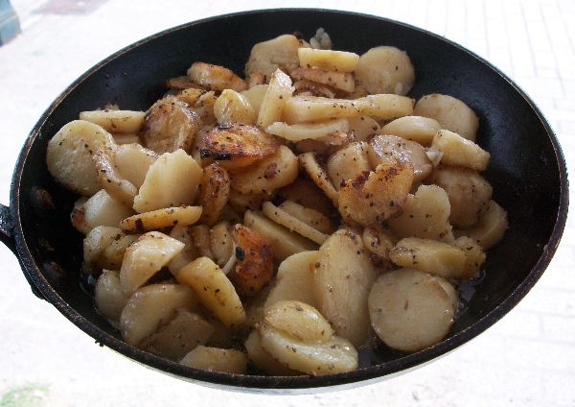 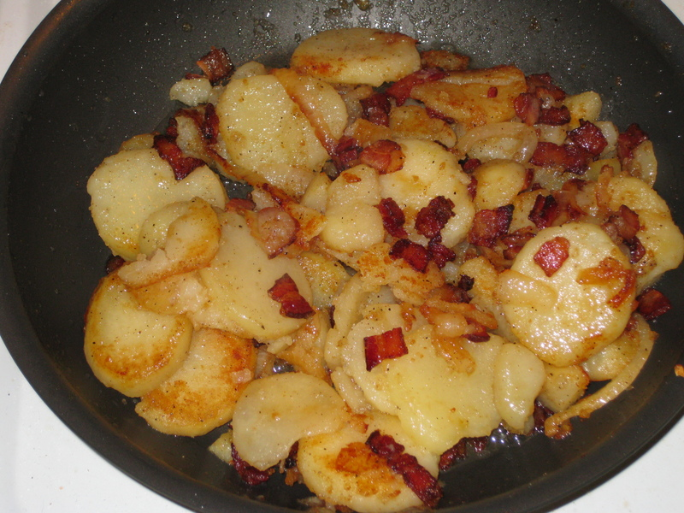 Recipe makes 4 servings.

A quick German favorite from leftover potatoes. The trick to success are cold potatoes, a good non-stick pan and PATIENCE. Make it a main dish by using onion and bacon or a side with potatoes only. Good with fried meat. Best use firm potatoes, others might cook to mush.
INGREDIENTS:

2 lbs potatoes, peeled and boiled 10 minutes
3 tablespoons oil
1/4 teaspoon salt
1/8 teaspoon black pepper
3 ounces bacon, diced (optional)
1 medium onion, diced (optional)
For garnish
1 tablespoon parsley, chopped

Directions:

Cut potatoes into evenly thick slices (about 1/8” – ¼” thick).

Use a large pan that will hold potatoes in a single layer, or use two pans. Heat oil over medium high heat. If using bacon and/or onion fry together until onion is translucent. Add potatoes, stir once to mix and then be patient!

DON'T stir until potatoes are nicely golden brown on the bottom, 3 - 5 minutes, only check for color occasionally.

Sprinkle with half the salt (use less salt when using bacon). Turn and fry the same way on the other side until nicely golden brown.

You might need to add a little more oil to the pan if all the oil is soaked up by the potatoes.

Taste with salt and pepper. Serve sprinkled with parsley.

