Rinderrouladen - German Beef Rolls (recipe serves 2)

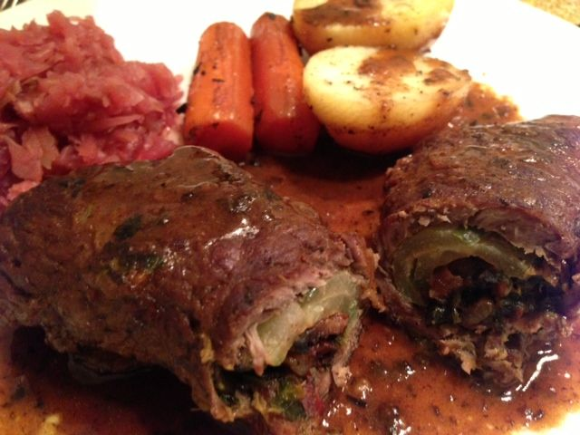

Traditionally served in Germany during festive occasions, but always served in German restaurants in the U.S., who hasn’t had this classic dish at their favorite German restaurant? Forget the high cost of dining out at a specialty-ethnic restaurant and make your own, gourmet German meal at home!

Ingredients:
2 beef scaloppini – ask your butcher to make them wide (only ⅛” thick) from whole Top-Round or Top Sirloin Steak - make sure they’re pounded out as thin as you can get them!
2 thick slices of bacon – each cut in half; with two halves left whole and two chopped.
2 dill-pickle spears (thin spears), or equal amount of dill slices
1 small onion (for the filling), minced, plus 1 large or 2 small onions (for the gravy), large-chopped
1 teaspoon dried marjoram
Salt & ground, black pepper
⅓ cup flour (to coat rolls for frying)
4 tablespoons butter
1 cup beef stock (for the gravy)
¼ cup dry red wine (for the gravy – make it a quality kind that you would drink)
2 small-to-medium carrots, peeled and halved lengthwise (for the gravy)
¼ cup parsley, finely chopped
2 teaspoons German or other spicy-brown mustard
2 small-medium Yukon Gold potatoes

Preparation:
Preheat oven to 325° F.

The beef scaloppini should weigh about .40 lbs. each on the butcher’s scale and be no more than ¼” thick, if not ⅛” thick (pound them using your rolling pin between two sheets of wax paper or plastic wrap). Sprinkle beef with salt and pepper, set aside.

Mix flour with about 1 teaspoon of salt and ½ teaspoon of pepper in a large, shallow plate. Set aside.

In a large, oven-proof skillet, sauté the long bacon halves until crisp; remove to paper towels. Fry the minced, small onion, the chopped bacon halves and marjoram in 2 tablespoons of butter until the onion is translucent and the bacon is crisp. Reserve the bacon fat in the skillet and remove the mixture to a bowl. Stir in the parsley.

Brush the beef scallops with about a teaspoon of mustard, then place a pickle spear, a crisp bacon strip and ½ of the filling on each slice of beef lengthwise along one edge. If possible, fold beef over ¼“ on the ends and roll up into packages. If not, roll them up tightly, leaving the ends open. Several wooden toothpicks can really get them sealed up pretty tightly!

Roll the meat in the seasoned flour. Reserve THE leftover flour.

Brown beef rolls in the bacon fat (add a little more butter, if needed). Remove from skillet when browned and place on paper towels to drain excess fat.

Add the large-chopped onion to the fat in the oven-proof skillet. Brown lightly.
Pour beef broth and wine over top of the onions, add carrots and stir. Bring to a boil, deglazing brown bits from bottom of skillet. Add back the beef rolls and the peeled potatoes; cover and bake for 1 hour.

When done cooking, remove the rolls and potatoes to a platter, discard onions, but plate the carrots. Remove and discard the toothpicks and plate the beef rolls whole or slice them, about ½” thick for serving.

Use a tablespoon of the reserved flour (or just use a little extra flour) to thicken the gravy. Whisk, until smooth. Stir into pan on the stove over medium-high heat and cook, stirring until thickened.

Plate beef rolls and potatoes; pour gravy over rolls & potatoes, and serve with sauerkraut or braised cabbage, and a few slices of Rye bread with a big stein of German Weiss beer.

