German Meat-Stuffed Onions in Smoky-Beer Sauce over Pureed Potatoes (Bamberger Zwiebeln mit Kartoffelpüree)

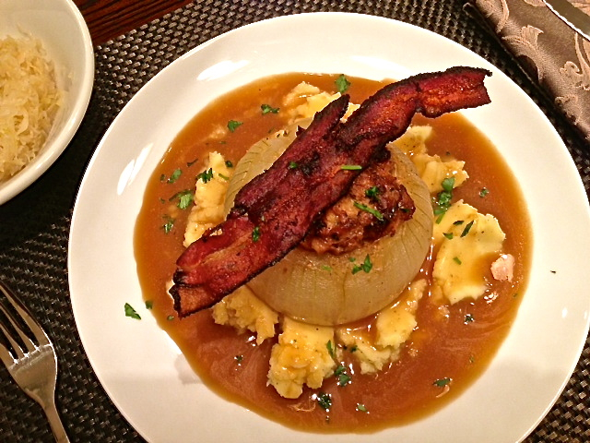

This German stuffed-onion dish is traditionally served with sauerkraut on the side (of course) and "Stampfkartoffeln" (or "Kartoffelbrei"), which are mashed or pureed potatoes. Prussian King Frederick the Great brought the sustaining, nurturing potato to the German people and died a national hero for it.

Ingredients:
5 ounces ground pork
2 large, mild onions or Bamberger onions – large, sweet Vidalia onions work nicely
1½ teaspoons fresh, chopped parsley
¼ teaspoon dried marjoram
1 small egg (or just half a medium or large one)
½ of a hard, Kaiser or white roll (about 1½ – 2 ounces in weight), torn into small pieces, soaked in milk 10 minutes then squeezed until nearly all the milk is out
¼ teaspoon salt
¼ teaspoon ground, black pepper
⅛ teaspoon ground nutmeg
1 cup ham or vegetable broth
¼ bottle of Rauchbier or Kellerbier – we prefer imported Schlenkerla brand Rauchbier (Urbock) from Bamberg, Germany sold in bottles holding just a little over a pint each
1½ teaspoons all-purpose flour
3 slices thick, smoked bacon (Räucherbauch in German)

Preparation:
Preheat oven to 350° F. Fry the bacon slices in a skillet until crisp. Remove to paper toweling to drain the grease. Cut the root-end off the onions so that they stand flat on a surface. Cut off the cap of the onion, peel off the dried outer skin and hollow out the middle to leave a half-inch wall around on all interior sides. I start by criss-crossing a pairing knife through the top and cutting out a wide parameter on top. I then use a teaspoon to dig out the rest of the insides (bits of onion flying all over the kitchen as I go). Don’t worry if you dig out the whole bottom and leave a hole down there because it’s no problem at all if that happens. Save as much of the onion centers as you can.

Chop the onion centers into small dice. Sauté them in the bacon grease in the skillet until translucent and sprinkle with the parsley and marjoram. Add the fried onion bits to the ground pork, the egg, the milk-soaked breadcrumbs and crumble up one of the fried bacon slices in a bowl. Mix together with your hands (I wear washed latex gloves), adding salt, pepper and nutmeg to taste.

Fill the hollowed-out onions with the pork mixture, mounding as necessary. Place the onions in a Dutch oven or deep, oven-proof pan or casserole dish with a lid. Pour the broth over them, cover and bake for an hour. Add more broth if necessary.

Pour the beer over the onions, season with a little salt and pepper, then cover and bake for another 30 minutes or until the onions are soft. Carefully remove the onions from the pan and place to the side.

Pour the broth from the roasting pan into a small saucepan or skillet. Stir 1½ teaspoons cold water into 1½ teaspoons flour. Pour this thin paste into the broth while stirring constantly. Bring to a boil on the stovetop to thicken. Cook for several minutes to remove the raw-flour taste. Season with salt and pepper, then strain through a sieve.

Garnish each onion with one of the remaining fried bacon slices over the top, then with a sprinkling of more chopped parsley. Plate each on an equal mound of mashed potatoes covered evenly with the sauce. Serve, naturally, with a glass of Rauchbier!

