Laura Calder’s Soupe de Madame Tizza for Two

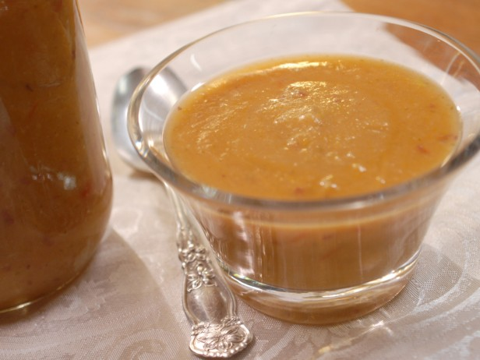

This is a very low-calorie recipe that Canadian Chef Laura Calder got from a French woman while she was over there learning to cook. It’s about 50 calories per 8-ounce serving. Note that you can jazz it up any way you like – I throw in a couple of chilis!

Ingredients:
5 ounces potatoes, peeled and chopped
1 medium-sized carrot, peeled and chopped
1 medium zucchini, chopped
1 artichoke heart, chopped
1 small leek, trimmed, chopped and thoroughly rinsed
1 small tomato, chopped
1 small turnip (not rutabaga), chopped
¼ stalk celery (3 – 4 ribs) with leaves, chopped
½ cube chicken or vegetable bouillon
1½ teaspoons olive oil
Salt and ground, black pepper, to taste

Preparation:
Put the potatoes, carrot, zucchini, artichoke heart, leek, tomato, turnip and celery in a large pot. Add the bouillon, olive oil and season to taste – it will need a bit of salt and pepper.

Cover with water. Bring to a boil and simmer until all the vegetables are tender, 20 to 30 minutes. Put the mixture through a food mill or blend with an immersion blender (I let it cool off a little and put it in a large food processor).

Reheat to serve.

