Salade Niçoise – another classic from France!

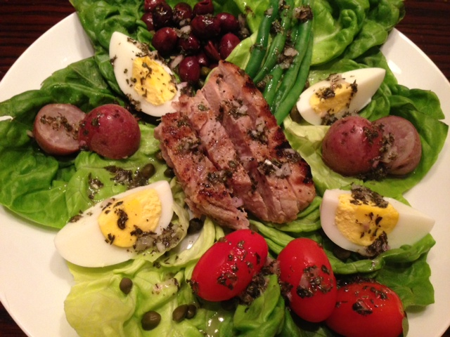

This dish is traditionally made with canned tuna in oil. But why not make it with lovely, grilled fresh tuna instead?

Ingredients per Serving:

Salad
1½ cups crisp, mixed salad greens or 3 - 4 large leaves Boston or Bibb lettuce
2 - 4 ounces fresh tuna fillet
1 to 1½ ounces anchovy fillets (optional)
1 hard-boiled egg, quartered or sliced
4 – 5 green beans, blanched and sliced in 2” pieces
3 – 6 cherry tomatoes, halved
6 whole, black olives
2 tiny new potatoes, boiled and halved (optional)
1 tablespoon capers

Vinaigrette
1 tablespoon lemon juice
2 tablespoons extra-virgin olive oil
1 very small shallot (not more than a teaspoon’s worth), minced
½ teaspoon minced thyme leaves (dried is fine)
¾ teaspoon minced basil leaves (dried is fine)
¼ teaspoon minced oregano leaves (dried is fine)
¼ teaspoon Dijon mustard
⅛ teaspoon salt
⅛ teaspoon ground, black pepper
⅛ teaspoon granulated garlic powder

Preparation:
Season the tuna fillet with a little salt, ground, black pepper and granulated garlic powder. Drizzle with olive oil and grill over medium-high heat to desired doneness. Slice grilled tuna.

Cover a wide plate with the salad greens. Top the greens artfully, in separate little piles over the plate, with tuna slices, egg, beans, tomatoes, etc. Whisk together the vinaigrette ingredients, then drizzle the salad with the dressing and a little coarse-ground salt and black pepper to taste just before serving.

