Roasted Fruit Dessert

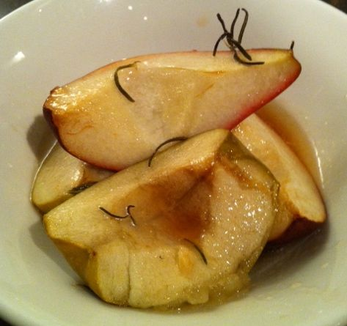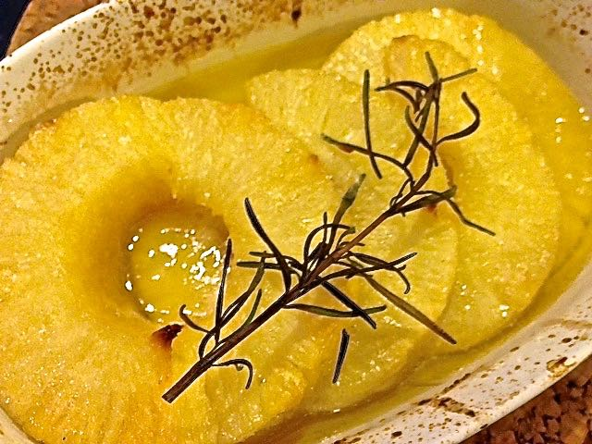

Ingredients per Serving:
2 – 3 pieces any hard fruit you like, such as pears, apples, strawberries, pineapple, mango
2 tablespoons sugar
1 – 2 sprigs fresh Rosemary, or two teaspoons dried
3 tablespoons lime juice
2 tablespoons butter, chopped into little cubes

Preparation:
Preheat oven to 400º F.

Prick large fruit skins and cut into quarter-sections; leave strawberries and such sized fruit whole.

Place fruit pieces in suitably-sized baking dish. Pour over the lime juice and mix it with the fruit pieces well. Pour over remaining ingredients.

Bake in preheated oven 25 – 30 minutes, until some gold appears on the fruit.

