Real Mayonnaise – recipe makes about 1 cup of the actual stuff from France

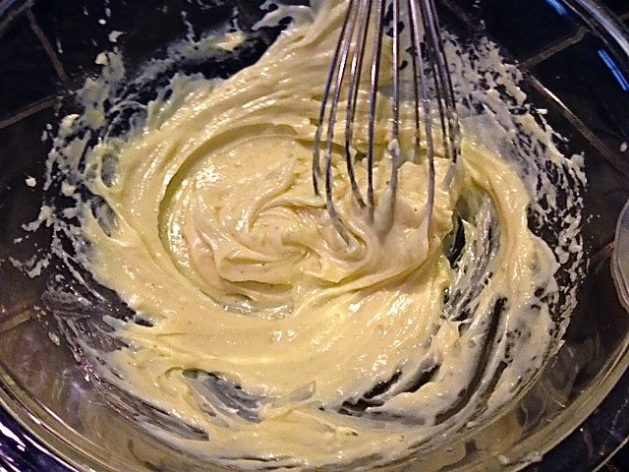

Ingredients:
1 large egg yoke, room temperature (see notes)
1 teaspoon Dijon mustard
¼ teaspoon salt
¼ teaspoon ground, white pepper
1 teaspoon lemon juice
1 cup good-quality olive oil

Preparation:
In a 1-quart mixing bowl, combine the egg yoke, mustard, lemon juice, salt and pepper with a large balloon whisk, mixing until foamy and pale. At this point, you may want to secure your mixing bowl to your counter with a damp towel or a rubber trivet to keep it from moving around as you complete the recipe. Whisking constantly, drizzle the oil, a few drops at a time, and then in a steady stream as the mixture emulsifies. Add additional salt, pepper and lemon juice to taste. Store, tightly covered, in the refrigerator for up to 7 days.

Notes:
All ingredients should be brought to room temperature. If your mayonnaise breaks, you can whisk in another room-temp egg yoke to save it. If it’s too thick, just add a tiny bit of water. Raw eggs should not be used in food prepared for pregnant women, babies, young children, the elderly, or anyone whose health is compromised.

Make a wonderful, homemade blue-cheese dressing with your mayonnaise to serve over lettuce wedges, sliced tomatoes or with Buffalo hot wings and crisp celery sticks. Here’s how. In a small bowl, whisk together all of the following ingredients:

4 ounces blue cheese, crumbled into chunks
½ cup low-fat buttermilk
¼ cup low-fat, Greek-style yogurt
½ cup of your mayonnaise
4½ teaspoons lemon juice
1 teaspoon each salt and ground, white pepper
1 teaspoon fresh thyme, leaves only, chopped – or ½ teaspoon dried (optional)

