Potatoes au Gratin for Two

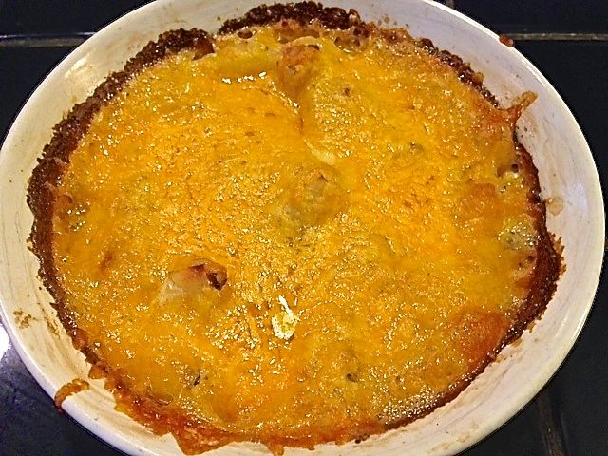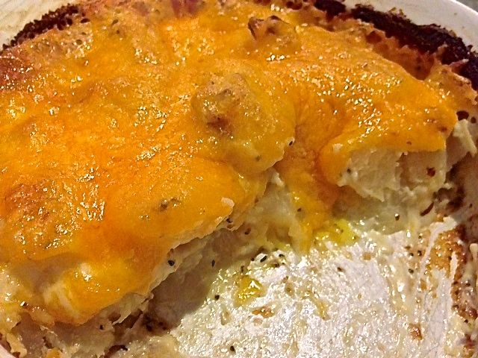

Ingredients:
1 whole Russet/baking potato, peeled
2 teaspoons butter, softened
9 tablespoons heavy cream
3 tablespoons whole milk
1½ teaspoons all-purpose flour
1 clove garlic, minced
1 teaspoon salt
Ground, black pepper, to taste
¼ - ½ cup sharp cheddar cheese, grated

Special Equipment: 1 Ramekin 5” – 6” in diameter and about 2” deep

Preparation:
Preheat oven to 400° F.

Grease the entire inside of the ramekin with the softened butter. Slice the potato into ½“-thick rounds, then quarter them into little wedges.

In a small bowl, whisk together the cream, milk, flour, minced garlic, salt, and plenty of ground, black pepper.

Completely cover the bottom of the greased ramekin with a layer of about half the potato wedges. Pour ½ of the cream mixture over the potatoes. Repeat with a top layer, ending with the cream.

Cover the ramekin with foil and bake for 30 minutes. Remove foil and bake for 20 minutes, or until the potatoes are golden brown and bubbling. Scatter the grated cheese over the top of the potatoes and bake for 3 to 5 more minutes, until the cheese is melted and bubbly.

Allow to stand for a few minutes before serving.

