Potato Casserole with Bacon and Caramelized Onion (Pommes Boulangères) for 2

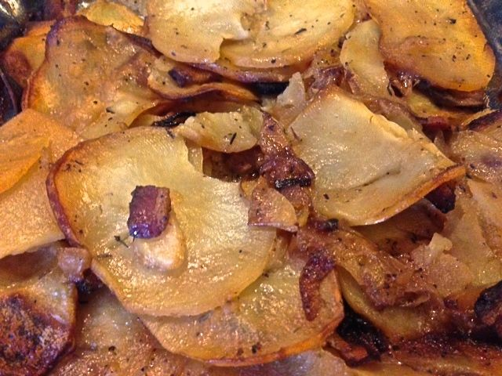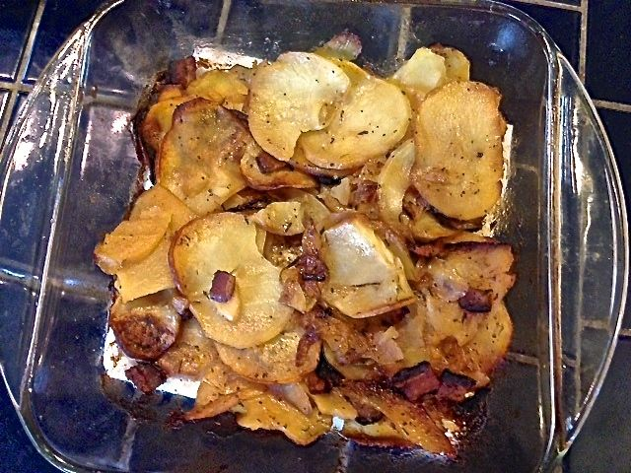

In the old days, this casserole was baked beneath a roast, allowing it to be seasoned by the savory fat and juices of the roast. To get the same luxurious results without the roast, this recipe renders a little bacon to lend a meaty, smoky flavor.

Ingredients:
1 slice thick-cut bacon, cut into ½“ pieces
1 small onion, halved and sliced thin
½ teaspoon salt
½ teaspoon dried thyme
¼ teaspoon pepper
⅓ cup + 2 tablespoons chicken broth
⅓ cup + 2 tablespoons beef broth
1 pound Yukon gold potatoes, peeled
2 teaspoons unsalted butter

Preparation:
Adjust oven rack to lower-middle position and heat oven to 425° F. Grease a small baking dish (8” x 8” or similar dimensions).

Cook bacon in a small saucepan over medium-low heat until crisp. Transfer bacon to paper towels. Season the onions in the bacon fat in the pot with ¼ teaspoon salt and sauté over medium heat, stirring frequently, until soft and golden brown, about 25 minutes, adjusting heat and adding water 1 teaspoon at a time if onion or bottom of pot becomes too dark. Transfer onion to a large bowl; add bacon, thyme, remaining salt, and pepper. Add broths to empty saucepan and bring to simmer over low heat, scraping bottom of pan to loosen any browned bits.

Slice the potatoes ⅛” thick (I use a mandolin so the slices are uniform in thickness (plus, it’s a lot easier and faster to use one)). Transfer to the bowl with onion mixture and toss to combine (don’t soak them first – I slice them right into the bowl off the mandolin). Transfer to prepared baking dish. Firmly press down on mixture to compress into even layer. Carefully pour hot broth over top of potatoes. Dot surface evenly with the butter.

Bake, uncovered, until potatoes are tender and golden brown on edges and most of liquid has been absorbed, 45 to 55 minutes. Transfer to wire rack and let stand for 20 minutes to fully absorb broth before cutting and serving.

