Pommes Frites
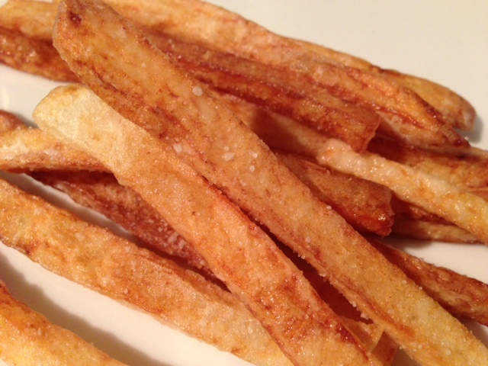

Ingredients:
Peanut oil – may use other vegetable oil for deep frying, but do not use canola oil (tastes fishy) or olive oil (it’ll catch on fire)!
2 large Russet (baking) potatoes, peeled
1 tablespoon cornstarch
Sea salt or kosher salt

Preparation:
Slice the peeled potatoes first in half, then cut off the ends so you have them even and flat. Sculpture the rounded sides so that they are uniformly flat and square. Slice into thin, rectangular planks ½” x ½” in uniform thickness (make them even thinner, if you can manage – just make sure they’re uniform). Rinse as much of the starch off of them as you can in a colander under cold, running water, then submerge them in a bowl of cold water for at least 30 minutes (you can leave them overnight, if you want).

Fill your fryer with the prescribed amount of oil and get it heated up, or pour at least one inch of oil into a deep pot on the stove and heat it to 350º F. over medium-high heat.

Drain the potatoes and dry them thoroughly with paper towels (before dabbing with the paper towels, we give them a good whirl in a salad spinner – those are widely available these days in most house-wares stores). Then dust them evenly with the cornstarch.

Drop the potatoes in small, manageable batches into the hot oil (don’t crowd them too much!) and cook for about 5 minutes, until golden brown. Remove them from the oil with a slotted spoon or wire skimmer, and drain on more paper towels. Sprinkle the hot fries immediately with salt, to taste.

Keep cooked fries warm on a foil- or parchment-lined baking sheet in a 250º F. oven as you cook the remaining potatoes.

