Savory Palmiers with pesto, goat cheese and sun-dried tomatoes.
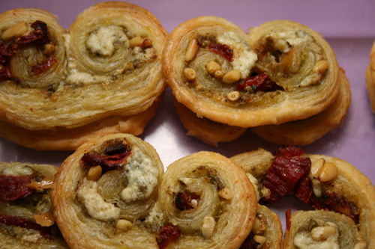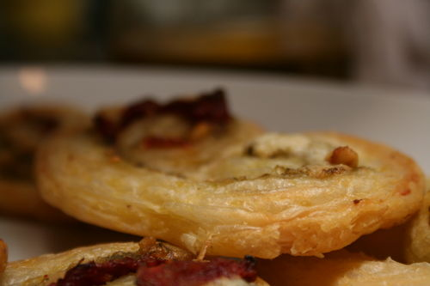
Ingredients
1 package frozen Pepperidge Farm puff pastry, defrosted
1/4 cup prepared pesto
1/2 cup crumbled goat cheese, such as Montrachet
1/4 cup finely chopped sun-dried tomatoes in oil, drained
1/4 cup toasted pine nuts
Kosher salt Adding salt depends on the saltiness of your pesto.
Directions
Lightly flour a board and carefully unfold one sheet of puff pastry. Roll the pastry lightly with a rolling pin until it’s 9 1/2 x 11 1/2 inches.
Spread the sheet of puff pastry with half the pesto. Then sprinkle with half the goat cheese, half the sun-dried tomatoes, and half the pine nuts.
Working from the short ends, fold each end halfway to the center. Then fold each side again toward the center until the folded edges almost touch. Fold one side over the other and press lightly. Place on a sheet pan lined with parchment paper. Repeat for the second sheet of puff pastry using the remaining ingredients. Cover both rolls with plastic wrap and chill for at least 45 minutes. Preheat the oven to 400 F. degrees. Cut the prepared rolls of puff pastry into 1/4-inch-thick slices and place them face up 2 inches apart on sheet pans lined with parchment paper. Bake for 14 minutes, until golden brown.
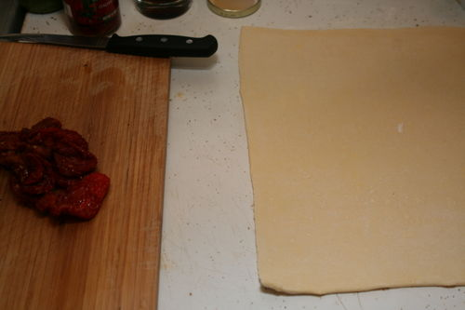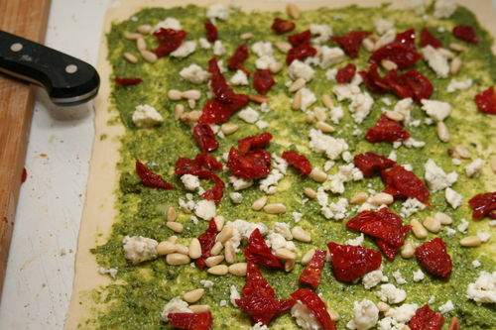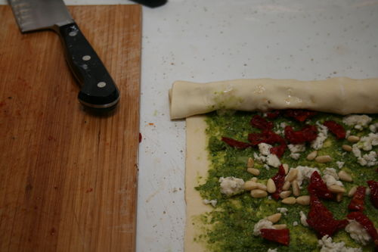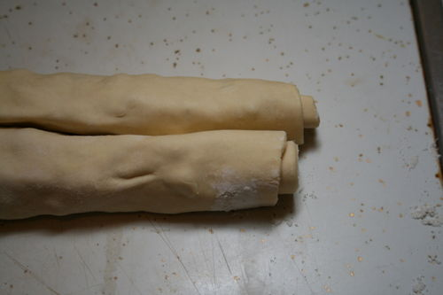
You can add anything to puff pastry. How about jalapenos and cheddar, or peanut butter and chocolate?
SWEET PALMIERS

Ingredients
- 2 cups granulated sugar
- 1/8 teaspoon kosher salt
- 2 sheets puff pastry, defrosted (recommended: Pepperidge Farm)

Directions
Preheat the oven to 450 degrees F.
Combine the sugar and kosher salt. Pour 1 cup of the sugar/salt mixture on a flat surface such as wooden board or marble. Unfold each sheet of puff pastry onto the sugar and pour 1/2 cup of the sugar mixture on top, spreading it evenly on the puff pastry. This is not about sprinkling, it's about an even covering of sugar. With a rolling pin, roll the dough until it's 13 by 13-inches square and the sugar is pressed into the puff pastry on top and bottom. Fold the sides of the square towards the center so they go halfway to the middle. Fold them again so the two folds meet exactly at the middle of the dough. Then fold 1 half over the other half as though closing a book. You will have 6 layers. Slice the dough into 3/8-inch slices and place the slices, cut side up, on baking sheets lined with parchment paper. Place the second sheet of pastry on the sugared board, sprinkle with the remaining 1/2 cup of sugar mixture, and continue as above. (There will be quite a bit of sugar left over on the board.) Slice and arrange on baking sheets lined with parchment.
Bake the cookies for 6 minutes until caramelized and brown on the bottom, then turn with a spatula and bake another 3 to 5 minutes, until caramelized on the other side. Transfer to a baking rack to cool.

