Potato Leek Soup for Two
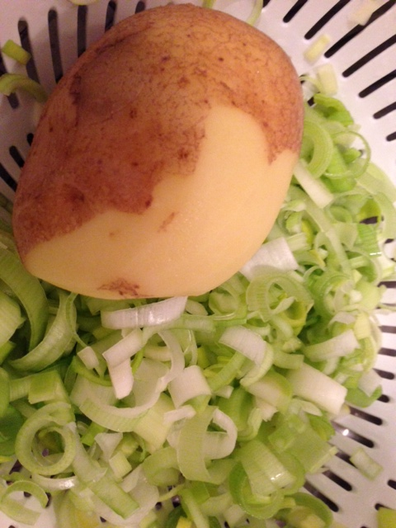

Though favored by British pallets, this soup recipe is actually French. Chill this soup before serving and you will have Vichyssoise!

Ingredients:
2¼ teaspoons butter
1 leek, thinly sliced and thoroughly rinsed (see notes)
1 small onion, chopped
2 medium-small Yukon Gold potatoes, very thinly sliced (see notes)
3 cups chicken broth (or enough to barely cover potatoes)
½ cup heavy cream
Salt, to taste
Ground, black pepper, to taste

Preparation:
Melt butter in a 3– to 4-quart pot over medium-high heat then add onions and leeks. Cook, stirring, until onions are limp and just slightly brown.

Add sliced potatoes to pot, then pour in enough chicken broth to just barely cover the potatoes. Cover and cook over medium heat until potatoes are tender (about 15 minutes). Using a potato masher, mash and stir potatoes until desired consistency is reached. As you mash the potatoes and the soup thickens, turn down heat and stir frequently with a large spoon to prevent scorching on the bottom.

Add one cup of heavy cream (or more if you desire) and salt and black pepper to taste. Cook 15 minutes more over low heat, stirring frequently, then remove from heat and serve.

Notes:
Make sure to clean leeks thoroughly and slice only the white and light green part of the leeks.

