Le Poulet à la Moutarde – Chicken Dijon (serves 2)
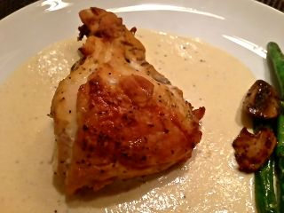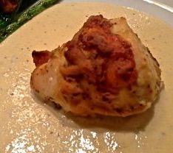
Ingredients:
1 bone-in, skin-on chicken breast “Supreme” (a breast half)
⅓ cup white wine – a good type that you will serve with the dish
⅓ cup Dijon mustard
Salt, to taste
Ground, black pepper, to taste
Granulated garlic powder, to taste
About 1 cup heavy cream (to make sauce)

Preparation:
Rinse the chicken off under cold, running water, then pat it dry and snip it into two, equal portions with kitchen sheers. Place the chicken pieces in a 9” x 9” baking dish. Prick the skin all over with the tines of a fork, season with salt, pepper and garlic powder, then coat each piece liberally with mustard. Cover with plastic wrap and refrigerate at least one hour up to 6 hours.
When ready to cook, preheat your oven to 350° F.
Add the wine to the bottom of the baking dish. Place the dish in the preheated oven, uncovered, and bake 45 minutes to 1 hour, until the juices run clear and the chicken is cooked through.
When the chicken is nicely browned on top, remove it from the oven and pour the fat drippings from the baking dish into a small skillet on the stove over medium heat. Place the chicken back in the oven to keep it warm.
Add the cream to the drippings with a sprinkling of salt and pepper. Bring to a boil, stirring continuously until the mixture thickens and reduces by at least half. Pour the drippings mixture equally on to two serving plates (enough to cover the bottom of each). Remove the chicken from the oven and plate half over the sauce on each plate. The sauce goes wonderfully with steamed or blanched asparagus spears or green beans. Serve chicken with crusty bread and a green salad on the side.

