Parisian Street-Wiener Sandwiches (les Sandwichs avec Saucisses au Fromage) for 2

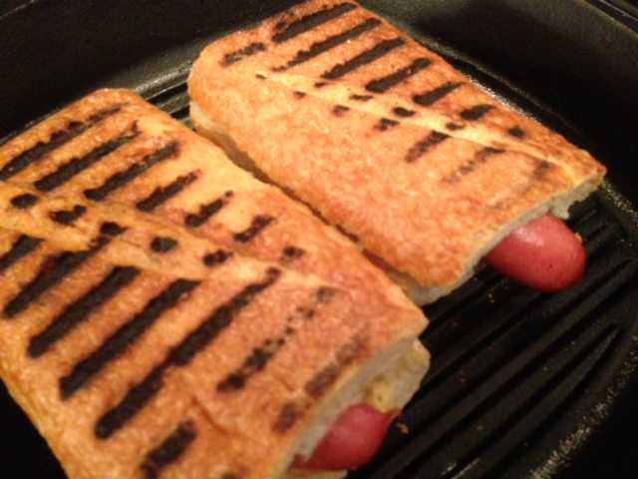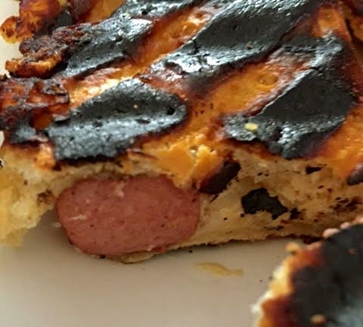

This is wonderfully decadent street food from Paris. I bought one of these sandwiches from an old French gal who was making them to order and selling them out of an RV trailer parked in a space on the sidewalk that she rented from the city, then I ate it while standing in the long line to get into the Paris catacombs!

Ingredients:
2 natural-casing wieners (I use Usinger’s brand)
2, 6” sections French-style bread
About an ounce of Gruyère, Grand Cru, Doux de Montagne or some other meltable, white French cheese
4 tablespoons Dijon mustard

Preparation:
Bring a large, flat grill pan to medium heat. Place the wieners on the grill-pan and heat them through well, leaving nice grill marks on them.

While the wieners are grilling, cut the loaf in half, then slice open top from bottom of each half to make two sandwiches. Dig out a shallow trench along the length of each sandwich top. Spread a good two tablespoons of Dijon mustard on the bottom half of each. Shred the cheese or slice it as thinly as you can, then spread the cheese evenly over the mustard layer on each sandwich bottom. Position a wiener in the trench you dug out of each top-half, then put the two halves together, forming the two sandwiches.

If you don’t have a Panini press, wrap the bottom of a large skillet or frying pan firmly with aluminum foil. Set aside.

Next, turn the heat down to low and place each sandwich on the grill pan, top-side down. Press down on them firmly with the aluminum-wrapped skillet, Panini-style. Let cook only for about one minute, just until nice grill marks appear. Then flip the sandwiches over and do the other (bottom) side, until the cheese is nicely melted.

