Le Poulet à la Crème Fraîche et Basil

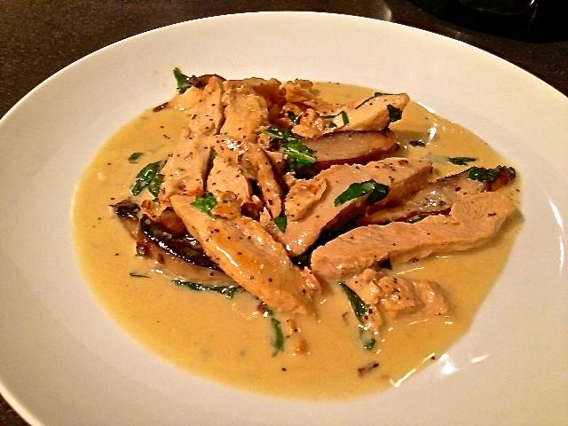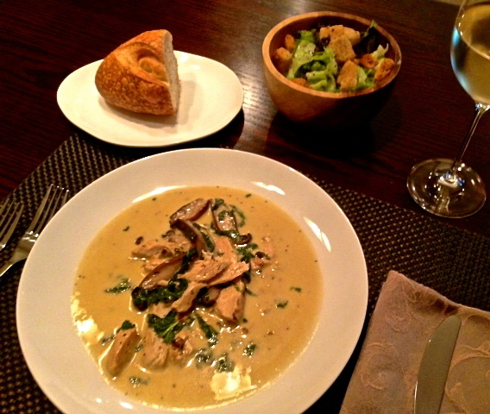

Wonderfully fast and fresh, this is a simple French recipe that calls for an optional ½ cup of diced tomatoes to be added in at the end, but which I prefer to leave out. My suspicion is that it is Provençal in origin due to the fresh basil and garlic.

Ingredients:
6 – 8 ounces skinless, boneless chicken breast, cut in 2”– 3” strips (see notes below)
¾ – 1 ounce fresh basil, to taste (I buy one of the plastic packs)
1 cup crème fraîche (see notes below)
2 tablespoons light/regular olive oil (for frying the chicken)
2 cloves garlic, minced
¾ teaspoon salt
½ teaspoon freshly-ground black pepper
1 medium portabella mushroom, sliced into strips same size as chicken (optional)

Preparation:
Mince the garlic. Slice the mushroom (remove dark-colored gills with a spoon). Wash, dry and chiffonade the basil leaves.

Cut the chicken into very thin strips, season with a sprinkle of salt, black pepper and garlic powder, then grill the strips in a grill-pan just so that nice grill marks appear (but see notes below to save time on this step).

Gently fry the chicken, garlic and, if using them, the mushroom strips in the oil in a skillet over medium heat, about 8 minutes, until the chicken is cooked through. Turn the heat down to its lowest position, add the crème fraîche, basil, salt and ground, black pepper. Heat through until completely warmed. Serve immediately with crusty bread and a green salad with a light vinaigrette.

Notes:
I use the ready-cooked/grilled chicken strips that are sold in the little boxes and bags in most supermarkets (antibiotics-free Nature’s Rancher brand). It costs about the same as purchasing fresh chicken, it tastes great, already has nice grill marks and saves a lot of prep time. The Vermont Butter & Cheese Company sells crème fraîche in pink, 8-ounce containers at some supermarkets and specialty grocers, like Trader Joe’s and Whole Foods.

