Le Biftec Français - French-style beef steak (pan-seared or grilled).

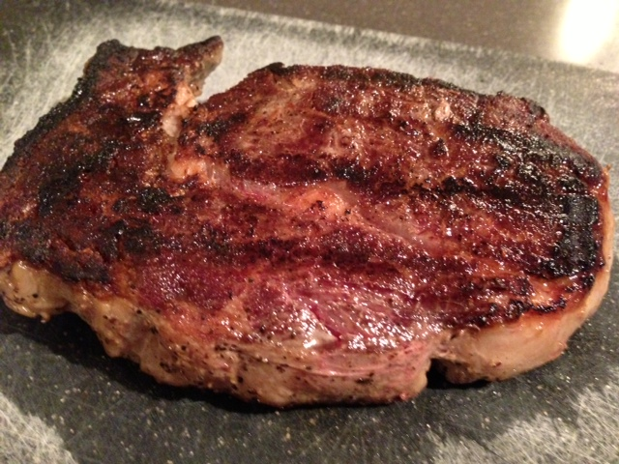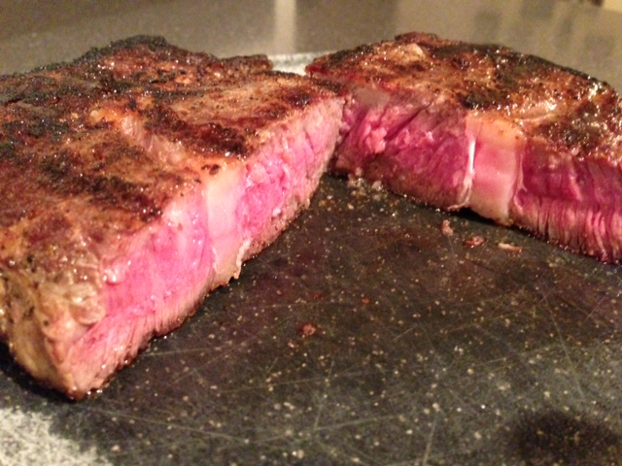

You’ll want steaks between 1” and 1½ “ thick. Season the steaks generously with salt, ground or cracked black pepper and garlic powder, then allow them to come to room temperature before cooking. Doing it this way slightly brines the meat for you.

In a Pan on the Stove:

In a skillet, heat a teaspoon of butter and a teaspoon of olive oil per steak over moderately high heat just until it starts smoking. Sear the steaks for 4 minutes (3 - 3½ minutes for thinner steaks) on each side for medium rare. A deep, dark crust should develop on all sides (be sure to tip the steaks over on their sides and brown them, too). Transfer steaks to serving plates and allow to rest 5 minutes.

On the Grill:

These times are total cooking times. Divide in half for each side (then divide in quarters, turning the steaks 90º and cooking in that position each quarter interval in order to achieve the nice criss-cross grill char marks). Times are approximate and will vary depending on the type of grill, fuel, weather conditions, etc. DO NOT CLOSE THE GRILL LID – GRILL THE STEAKS “AL FRESCO!”

Thickness Rare Medium Well Heat

1" 8-10 12-14 16-20 High
1½” 10-14 16-20 22-26 High
2 12-16 18-22 24-28 Medium

Serve with a red, French wine (like le Beaujolais Neuveau), a light, green salad and les “gougeons” de pommes frites (French fries/chips). Crumbling French blue cheese over the hot steaks adds lots and lots of just the right touch of perfect decadence, too!

