Thick, rich and beefy French Onion Soup (La Soupe à l'Oignon) – recipe serves 2

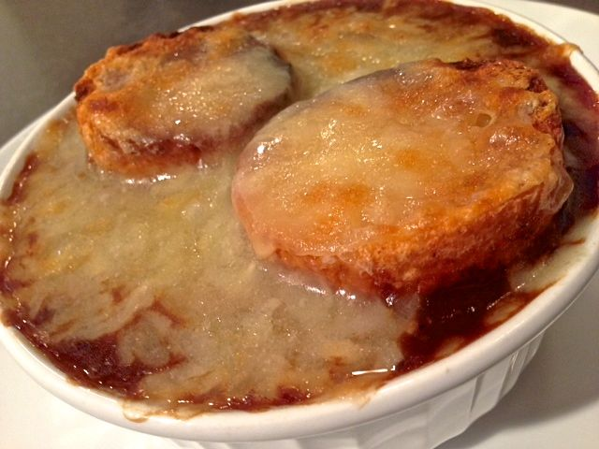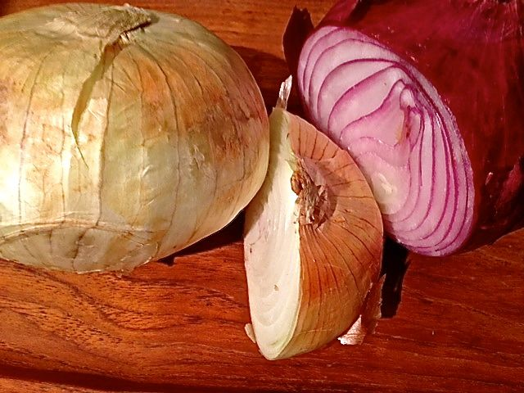

Ingredients:
2 ounces (half a stick) unsalted butter
2 very large yellow and/or red onions, quartered and thinly sliced
1 large garlic clove (or 2 small), minced
1 bay leaf
⅛ teaspoon dried thyme
½ teaspoon salt
¼ teaspoon ground, black pepper
¼ teaspoon sugar
½ cup dry red wine or vermouth (I use 3 tablespoons of each)
2 teaspoons all-purpose flour
3 cups beef broth
4 baguette slices ½” thick (2 per serving), toasted
4 ounces gruyère cheese, grated

Equipment: 2 medium ramekins or ovenproof soup bowls

Preparation:
Melt the butter in a large saucepan over medium-high heat. Add the onions and mix in the garlic, bay leaf, thyme, sugar, salt and pepper; cook, stirring often and adjusting the heat down so as not to burn the onions, until they’re very soft, darkly caramelized and quite reduced. This can take up to an hour, depending on all factors.

Add the wine, bring to a boil, reduce the heat to medium-low and simmer until the wine has evaporated and the onions are practically dry, about 5 – 8 minutes.

Discard the bay leaf. Dust the onions with the flour and give them a good stir. Keep the heat down to medium-low so the flour doesn't burn, and simmer, stirring often, for 10 minutes to cook out the raw flour taste.

Now add the broth, bring the soup back to a simmer, and cook for 10 minutes. Season more to taste with salt and pepper. Cover and keep on low heat until ready to serve.

When ready to serve, ladle the soup into ovenproof bowls, top each with 2 slices of bread and top generously with cheese. Put the bowls into the oven under the broiler and melt the cheese.

