French Chicken Dumpling Soup (Bouillon de Poulet avec des Quenelles de Volailles)

Recipe makes 4 servings.

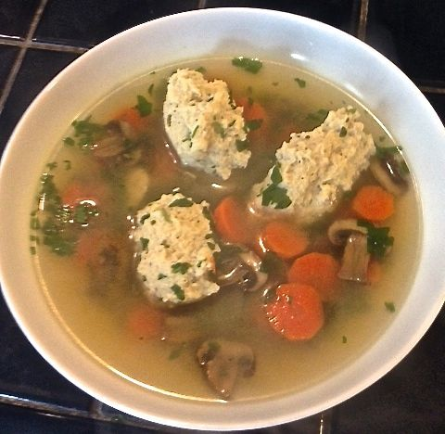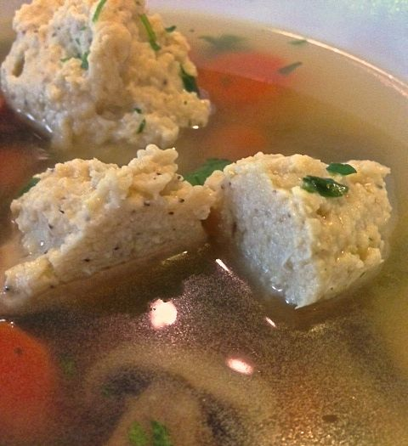

This is a good example of what you will not find served in restaurants in France, but served by the French in their homes. Hailing from the Lyon-Alps region of France, it’s delicious and quite easy to make – perfect when you have a cold or hangover.

Ingredients for the quenelles or dumplings:
7 ounces raw, skinless chicken breast, cut into pieces for the food processor
5 slices (about 3½ ounces) white bread, crusts removed and torn into pieces
6 tablespoons, plus 1½ teaspoons half-and-half
1 egg, plus 1 egg yolk
1½ teaspoons salt
½ teaspoon ground, black pepper
⅛ - ¼ teaspoon ground nutmeg
For the stock:
6½ cups chicken stock
2 large carrots, sliced about ½” or less
5 button or crimini mushrooms, thinly sliced
½ bunch flat-leaf parsley, finely chopped and divided in half

Put the stock, carrots and half of the parsley in a large pot and bring to a boil, covered. After the carrots have cooked until fork tender, put in the mushroom slices and continue to simmer while you make the dumplings.

To make the dumplings, put dumpling ingredients into a food processor and process until you have a smooth paste. Make 9 - 10 oval-shaped dumplings by rocking the batter back and forth between two large serving spoons. They don’t have to be perfect, but it’s important that they are all about the same size so they cook evenly together. Drop the quenelles into the stock and cook 5 minutes for large and 3 minutes for small. They’ll float to the surface when done. These are also served with tomato sauce instead of in soup. Check for seasoning and serve immediately garnished with remaining parsley on top.

