Chicken Cordon Bleu for Two

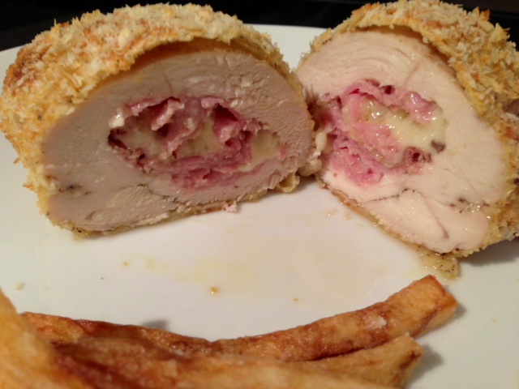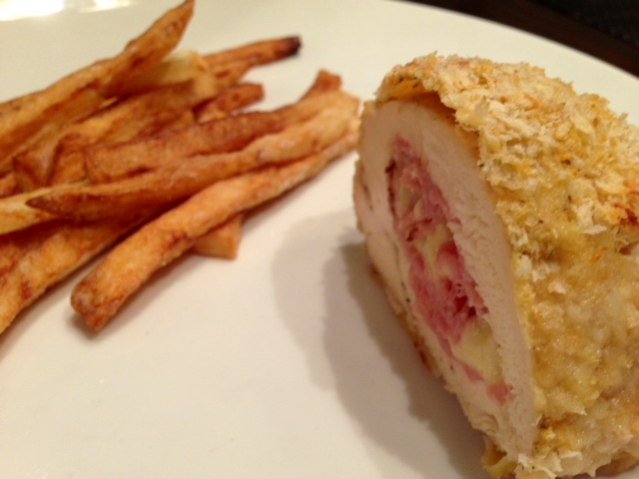

Though named after the famous cooking school in Paris and inspired by French culinary technique, this recipe is actually American (the French do this type of thing with veal, not poultry). One of these is plenty enough for me and my #2!

Ingredients per Serving:
1 fat chicken “supreme” (boneless, skinless half chicken breast)
½ cup breadcrumbs - I like Japanese panko breadcrumbs (for breading)
1 egg
1 tablespoon Dijon mustard
½ cup flour (for breading)
2 slices deli ham per serving
½ cup shredded Gruyère cheese per serving

Preparation:
Preheat oven to 450° F.

Create a pocket incision in the thickest part of each chicken breast: Insert a pairing knife and make an incision about 2 inches long. Gently push the blade in and sweep it through the whole breast so that it cuts a pocket about ¼” in from the outside of the flesh all the way around the edges. The smaller you can make the incision, but the bigger the interior cavity you can create the better. Set aside.

Make two ham-and-cheese bundles by tightly rolling up ¼ cup cheese in a ham slice. Cut the ends of each roll-up to size so they match the size of the breast, then shove them as deep into the pocket that you created in the chicken (don’t worry about trying to keep the rolls pretty!). Press the pocket closed – mold the flesh together well. Season the stuffed breast with salt and pepper, then place on a plate, cover tightly with cling-wrap and refrigerate 20 minutes (this allows the flesh to bind together so it’s held intact while baking).

Beat the eggs and mustard together in a bowl. Spread the flour on one plate, the egg-wash on a second and the breadcrumbs on a third. Coat each chicken breast in the flour, patting off any excess, then dip in the egg-wash and coat thoroughly, then coat well with the breadcrumbs.

Place on a foil-lined baking sheet and bake on the very bottom oven rack at 450° F. for 10 minutes. After that first 10 minutes, move the baking sheet to the center rack, lower the temperature down to 400° F. and bake for an additional 20 minutes. After the final 20 minutes, check to see that the breast meat in the thickest part of each supreme is 160° F. with a meat thermometer. Let the chicken rest 5 minutes under a loose, foil tent before serving.

