French Cheese and Potato Nests (Nids de Tartiflette) for Two

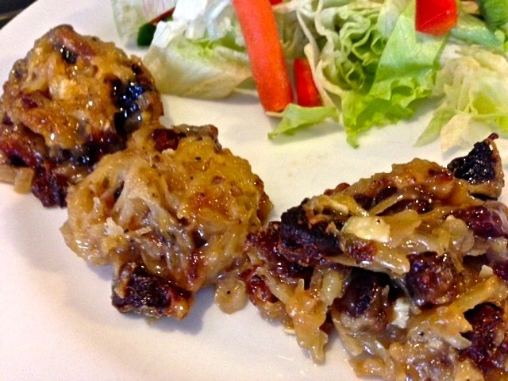

Not the most attractive dish, but delicious, this was created in 1980 by Reblochon cheese makers in the French Alps. It’s a cheesy potato gratin, traditionally quite a heavy winter staple. But, made this way, you can serve it on a hot day with a salad.

Ingredients per Serving:
1 teaspoon soft butter
6-ounce waxy potato (a medium-small one) – I like using Yukon gold
2 – 3 ounces lardons (ask your butcher for unsliced pork belly) or smoked bacon
1 small bay leaf
1 clove garlic, finely chopped
⅓ of a large onion or 1 very small one (about 2 ounces), finely chopped
2 tablespoons dry white wine
3 ounces Reblochon or other stinky, soft French cheese, cubed

Preparation:
Preheat the oven to 350° F. and grease two to four cups of a muffin tin (depending on size of the cups) with the butter.
Peel the potato and grate it lengthwise to make long, thin strands. Squeeze as much of the water out of them as you can. Season with a little salt and black pepper.
Season the lardons with a little salt and black pepper, put them in a small frying pan and fry until they’re crispy and golden brown (I like to render all of the fat out – I do it in the frying pan on a grill outside because they stink up the whole house!). Add in the bay leaf, garlic and onion and sauté until the onion is caramelized. Add in the wine and reduce until only a couple of teaspoons of liquid remain. Remove the bay leaf. Stir in the potato strings and take off the heat; stir in the cheese cubes.
Divide the potato mix among as many cups in the greased muffin tin as are needed and bake until golden brown and bubbling, 15 to 20 minutes. Spoon out onto s serving plate and serve hot.

