Braised Leeks for Two

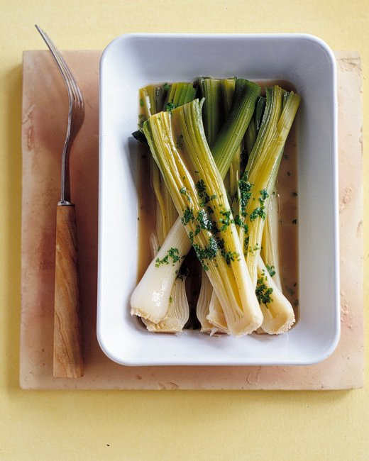

This is a traditional way to prepare leeks as a side dish in French cuisine.

Ingredients:
2 smaller-sized leeks, (1¼ to 2 pounds)
½ cup chicken or vegetable broth
½ cup dry, white wine
1 tablespoon cold, unsalted butter
1 tablespoon coarsely-chopped, fresh parsley
Salt and ground, black pepper

Preparation:
Remove outer leaves; cut dark-green ends from leeks. Trim roots just up to the base of the leek leaves – take special care to keep leaves attached (you want them to hold together). Halve lengthwise; rinse thoroughly under cold, running water to remove grit.

In a skillet large enough to accommodate the leeks, add the butter and swirl it to melt. Once it’s bubbling and a bit brown, place in the leeks cut-side down; let them fry 3 minutes on each side, until lightly colored. With the leeks facing cut-side down in the skillet, add in the broth, wine, salt and pepper; cover and cook over very low heat, turning once, until easily pierced with the tip of a paring knife, 15 to 25 minutes (depending on thickness of the leeks). Using tongs, transfer leeks to a platter.

Remove from heat. Dress with coarsely-chopped parsley and a bit more salt right at the white tips of the leeks (that’s apparently how the French do it), and sprinkle black pepper over all of the leeks.

