Bathed Bread (Pan Bagnat) for Two

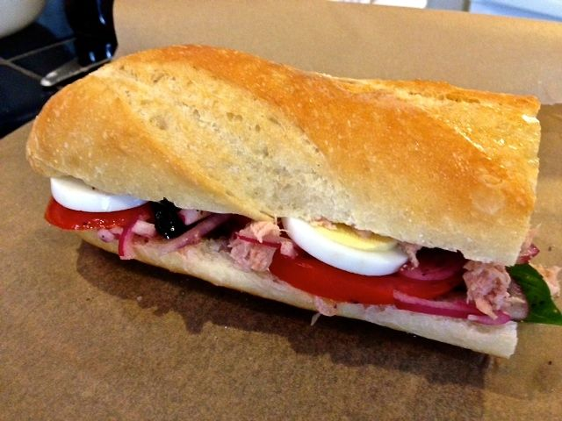

Dripping with the oil, vinegar and tomato juices, these sandwiches are quite wet (hence “bathed” bread). These were created quite accidentally – people would make them and take them wherever they were going and discover that they were sopping wet at their destinations. They eventually acquired a taste for them that way.

Ingredients:
1 very ripe tomato, sliced
1 large shallot or ½ a small red onion, thinly sliced
8 – 12 fresh basil leaves, whole
2 tablespoons red wine vinegar
Salt and ground, black pepper, to taste
½ a baguette or 2 small baguettes
1 clove garlic, halved
Extra-virgin olive oil, for drizzling
1½ ounces black olives, pitted and sliced (I use the cured French kind)
1 hard-cooked egg, peeled and sliced
6 ounces canned tuna or thinly sliced salami or other hard sausage (optional)

Preparation:
Mix the tomatoes, onions and basil leaves in a bowl. Season with vinegar, salt and pepper. Set aside to marinate for 5 minutes.
Cut the baguette(s) in half lengthwise and pull out about two-thirds of the middle, leaving a crusty bread shell (make breadcrumbs out of the insides for another use later). Rub the insides with the garlic halves and drizzle generously with olive oil.
Fill the cavity with the tomato mixture. Spoon any remaining juices over the top of the tomato mixture. Make a layer of olives. Lay the sliced egg over top and season them with a little sprinkling of salt and pepper. Next, layer over the tuna or sausage slices (if including), season with salt and pepper, and put the top of the bread back on, pressing down well. Wrap in parchment paper until serving. The longer it sits, the more the flavors will soak into the bread.

