Transylvanian Goulash – recipe serves 2.

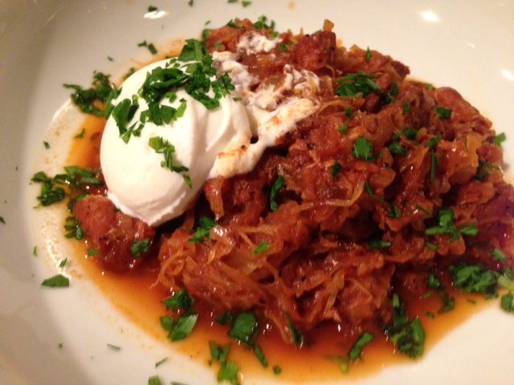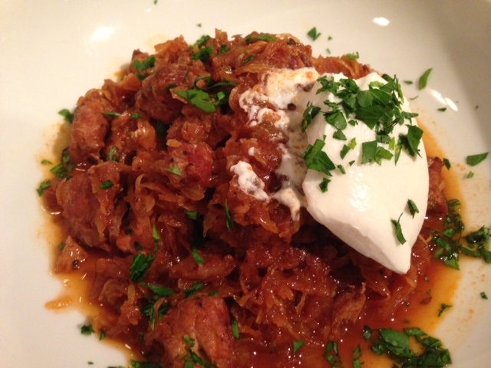

Ingredients:
½ pound pork center-cut chops or pork loin, cut into 1" dice
½ pound sauerkraut, drained and rinsed well
1 small onion (4 – 5 ounces), chopped
2 cloves fresh garlic, minced
1½ cups pork, chicken or vegetable broth
⅓ cup tomato sauce
1 tablespoon olive oil
1 tablespoon hot Hungarian paprika
¾ teaspoon caraway seeds
Salt, to taste
Ground, black pepper, to taste
Sour cream, a couple of dollops (for garnish - optional)
Fresh parsley, chopped (for garnish – optional, but looks pretty)

Preparation:
In a small saucepan, heat the oil over medium heat; add the pork, season with salt and pepper and brown on all sides. Remove pork to the side. Next, add the onion and garlic and a little more oil to the hot saucepan, season with salt and pepper and sauté until the onion is soft and a bit caramelized.

Layer the onion/garlic mixture, the pork cubes, and the sauerkraut into a small (2-quart) slow-cooker, alternating layers. Combine the broth, salt, paprika, caraway seeds, and tomato sauce; pour over the pork. Cover and cook on "high" for 10 – 12 hours with the lid cocked to allow the sauce to reduce.

Serve the goulash in wide bowls with a dollop of sour cream and garnished with a sprinkling of chopped parsley, if you like.

