Basic Hungarian Goulasch

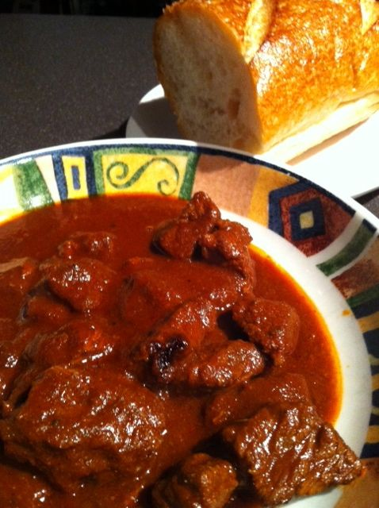 Recipe serves 2. 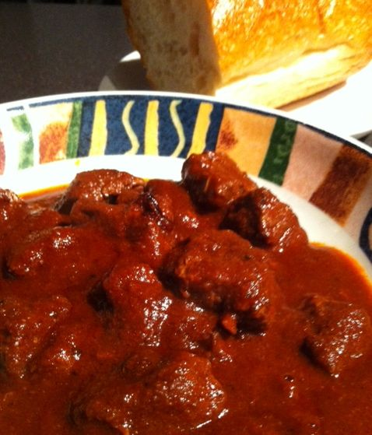

This is the simplest and most traditional recipe for this dish. Serve the beef in the rich sauce alone, or serve it over boiled noodles or potatoes.

Ingredients:
¾ - 1 pound rump roast, cut into 1½” cubes
6 tablespoons butter, bacon grease and/or vegetable oil
1 medium-sized white onion, finely minced*
2 teaspoons red-wine vinegar
2 tablespoons Hungarian paprika
1 teaspoon salt, divided in half (two ½ teaspoons)
½ teaspoon ground, black pepper
4 tablespoons tomato paste
½ cup beef broth or water
1 clove garlic, finely minced*

Preparation:
Heat fat in a large saucepan over medium-high heat. Season onions with a little salt and sauté until softened and a bit caramelized, stirring frequently. Remove onions from the saucepan and set aside.

In a paper bag, combine the paprika, half the salt and all the pepper. Toss the beef cubes in with the spice mixture, seal the bag and shake it really well to get the beef thoroughly coated with the spices. Bring the saucepan to very high heat until the fat is sizzling or even smoking, then empty all the contents of the bag into the saucepan and brown the meat well on all sides. Return the onions to the saucepan; mix in the tomato paste, broth/water, vinegar, garlic and remaining salt.

Reduce heat to low, cover and simmer, stirring occasionally, 2 to 3 hours, or until the meat is tender. Or transfer it all to a slow cooker and let it sit on the low setting 8 – 10 hours. Check seasoning before serving. If the sauce is too thick for your liking, thin it with water.

* I don’t like the specs of onion and garlic littering the broth, so I replace the onion with a tablespoon of granulated onion powder and the garlic with 1 teaspoon granulated garlic powder. I add them to the spice mixture in the paper bag.

