Shchi (“Щи” in Russian - pronounced “Shhh-Chee”) - Russian Cabbage Soup for Two

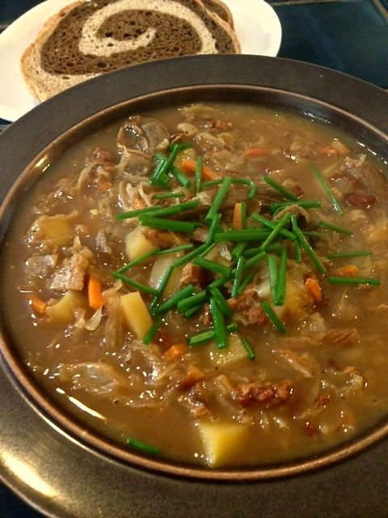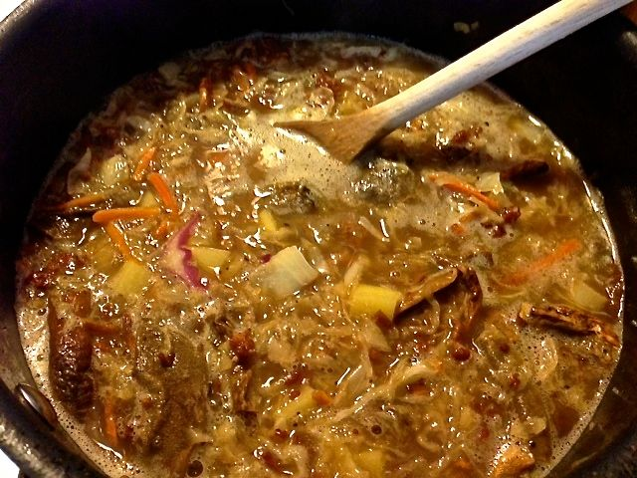

As early as the 9th century, tangy shchi has been a staple on the Russian table. Russians have a proverb that goes ”Щи да каша – пища наша.” (Shchi da kasha – pishcha nasha ”Shchi and kasha are our staples”). You can use any kind of meat in shchi, like ground beef, cooked chicken or ham, or even make a vegetarian version by omitting the meat and using vegetable broth – I make chicken-tasting, vegetarian broth with Knorr’s Aromat seasoning.

Ingredients:
3 cups chicken, beef or ham broth
1 ounce dried porcini mushrooms
¼ cup (4 ounces) ground pork or sausage out of the casing
1 medium waxy potato, peeled and chopped into small ½” dice
1 cup (8 ounces) sauerkraut, with juices
½ cup (that’s volume, not weight) fresh cabbage, finely chopped or shredded
½ cup onion, finely chopped
1 very small carrot (about ¼ cup’s worth), shredded
Fresh dill, scallions and/or chives, minced, for garnishing
Sour cream, for garnishing (optional – I hate it and leave it out)

Preparation:
Rehydrate the mushrooms by placing them in a measuring cup and pouring in
boiling water up to the 1-cup mark. Let them soak 15 minutes, then strain the
mushroom liquid through a coffee filter or paper towel into a small bowl in
order to remove the grit. Reserve this rich liquid for the next step.

Crumbling well, season and fry the pork in a medium-to-large saucepan until
crispy. Supplement the pork fat with a little butter or oil to cook the onions and
carrots. Season with salt and pepper. Sauté until they are tender. Add in the
broth, mushrooms and mushroom liquid. Bring to a boil and add in the potatoes,
cabbage and sauerkraut. Reduce the heat to a simmer, cover the pot and cook
until the potatoes and cabbage are tender, 20 – 30 minutes.

Serve soup garnished with fresh herbs and a dollop of sour cream in each bowl.
Serve with Russian black bread or rye bread.

