Russian Pan-Fried Cauliflower

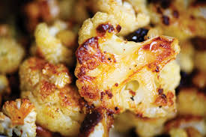

This recipe is a nice accompaniment to meat entrées.

Ingredients:
1 small head or ½ a large head of cauliflower, chopped into florets
8 tablespoons butter (1 stick)
¾ cup all-purpose flour
Salt and ground, black pepper, to taste

Preparation:
Boil the cauliflower florets for about 6 minutes, until tender. Then drain well and dust with the flour (I shake them with the flour in a paper bag).

Dump the boil water out of the pot and wipe it dry. Melt the butter in the pot over medium heat. Add in the cauliflower and stir-fry until crisp and golden brown.

Season with salt and pepper, then serve immediately while still nice and hot.

