Russian Cucumber Salad (recipe serves 2)

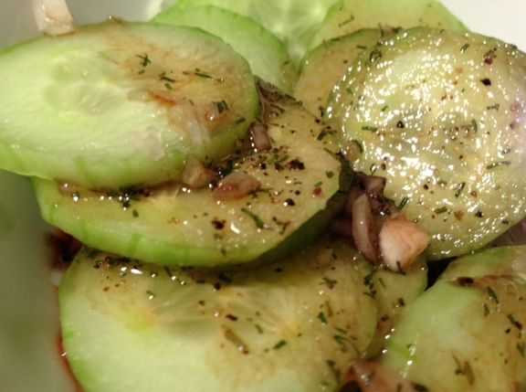

Ingredients:
1 large English/”seedless” cucumber, peeled and thinly sliced
1 small shallot, peeled/minced
3 tablespoons good olive oil
2 tablespoons balsamic vinegar
¼ teaspoon dried dill weed
⅛ teaspoon each salt & ground, black pepper

Preparation:
Combine cucumbers and shallots. Whisk together oil, vinegar, dill weed, salt & pepper. Combine oil/vinegar and cucumber/shallots just before serving.

