Russian Beef Stroganoff (recipe serves 2)

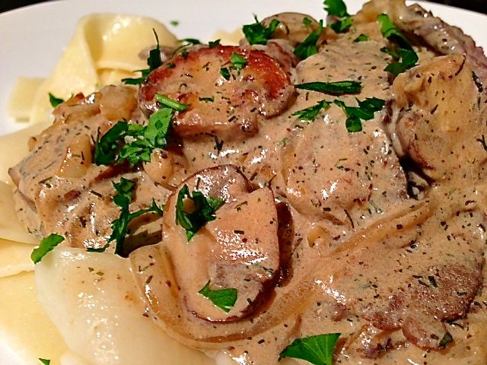

I learned this recipe from a Soviet defector to the United States back in the very early 1980s who was one of several teaching me and Army comrades the Russian language.

Ingredients:
½ pound flank or other flat steak, tenderized with fork tines and sliced into 2” strips
1 medium onion, peeled, halved and very thinly sliced
4 ounces button mushrooms, thickly sliced
8 ounces sour cream (go ahead – use fat free!)
2 cloves garlic, minced
2 teaspoons parsley, finely chopped - divided
1 teaspoon fresh dill weed, chopped (dried will do if you don’t have fresh)
½ teaspoon Worcestershire sauce
¼ teaspoon salt
¼ teaspoon ground, black pepper
¼ teaspoon butter
4 ounces of cooked, flat eastern European-style egg noodles

Preparation:
Season the beef slices with the salt and pepper. Heat the butter in a medium-sized skillet over medium-high heat until it turns brown and starts to smoke a bit. Brown the seasoned beef in it, then remove the beef to the side and turn the heat down to medium.

Sauté the onions, garlic, dill and mushrooms in the remaining fat in the skillet until the onions and mushrooms are wilted and slightly caramelized. Season with a little sprinkling more of salt and pepper, then add back in the beef with the sour cream, and Worcestershire sauce. Cook until it’s heated through.

Plate 2 ounces of noodles on each of two serving platters. Serve Stroganoff over the cooked noodles and garish with the chopped parsley. This goes wonderfully with the recipe for Russian Cucumber Salad.

