Romanian Sweet Pepper Salad for 2

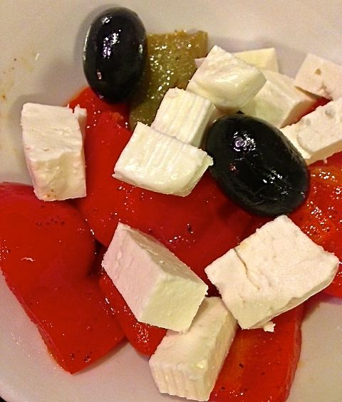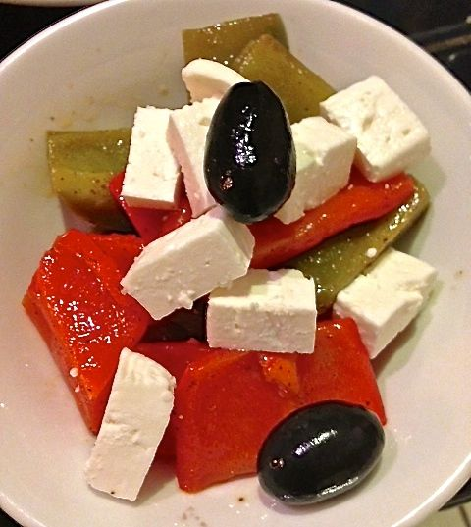

This crisp, delicious Romanian salad is quite versatile. It’s served as a tapa, it gets added to cooked pasta, it’s served on crostini, as well as a side dish.

Ingredients:
2 average-sized green bell peppers
2 average-sized red bell peppers
3 tablespoons white wine vinegar (I like champagne vinegar)
1 tablespoon sherry
1½ teaspoons Worcestershire sauce
3 tablespoons olive oil
½ teaspoon salt
¼ teaspoon ground, black pepper
1 tablespoon sugar
½ - 1 teaspoon Hungarian paprika, more or less to taste
6 pitted black olives
4 ounces feta cheese, cut into small cubes

Preparation:
Wash the peppers and deseed them. Cut each into 8 strips.

Fill a large saucepan or pot (whatever the pepper slices will fit in) half way with water. Bring to a rolling boil, then add in the pepper slices; blanch for 5 minutes. While they blanch, prepare an ice bath for the pepper strips in a large enough bowl. When the 5 minutes is up, plunge the pepper strips into the ice bath and allow to cool in it for about 5 more minutes.

While the peppers cool, make a marinade by mixing together well the vinegar, sherry, Worcestershire sauce, oil, salt, pepper, sugar and paprika. Check for seasoning.

Add the peppers to the marinade and coat them well. Cover and refrigerate for 24 hours. I do it in a quart-sized Ziploc bag.

When ready to serve the next day, divide the peppers equally out on 2 plates. Spoon some of the remaining marinade over each, then garnish each on top with 3 olives and 2 ounces of the feta cubes. Serve immediately.

