Romanian Apple Cake – recipe makes 12 servings

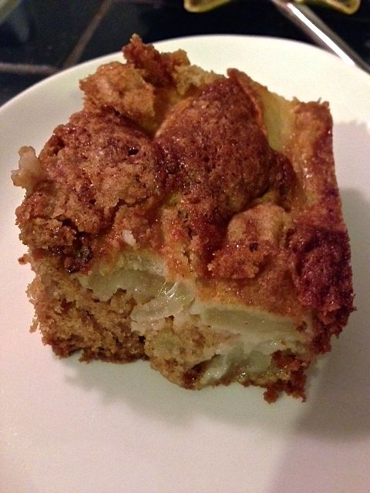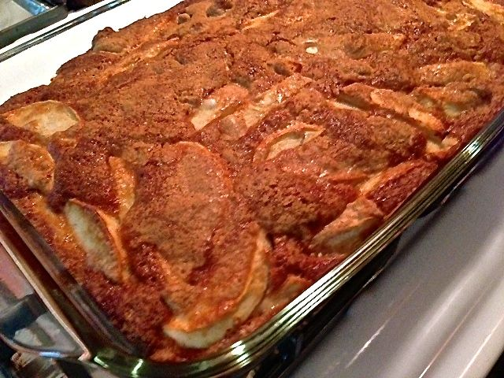

From the land of Dracula’s castle, apples, eggs, cinnamon and walnuts come together in a sweet pastry with lots of texture.

Ingredients:
5 honeycrisp apples, or whichever kind you like
3 eggs, beaten
1½ cups sugar
¾ cup vegetable oil
1 teaspoon baking soda
1 teaspoon ground cinnamon
1 teaspoon vanilla essence
2 cups all-purpose flour
¾ cup chopped walnuts

Preparation:
Preheat oven to 360° F.

Grease and flour a 9” x 13” cake pan. Peel and core the apples, then cut them into 1” slices. Set them aside.

In a large bowl, whisk together the eggs and sugar until well blended. Mix in the oil, baking soda, cinnamon and vanilla. Sift the flour and stir in a little bit at a time just until incorporated. Fold in the apples and walnut pieces.

Pour the batter into the baking dish. Bake for 55 minutes, or until a toothpick inserted in the center comes out clean. Serve warm or at room temperature.

