Hungarian Schnitzels for Two

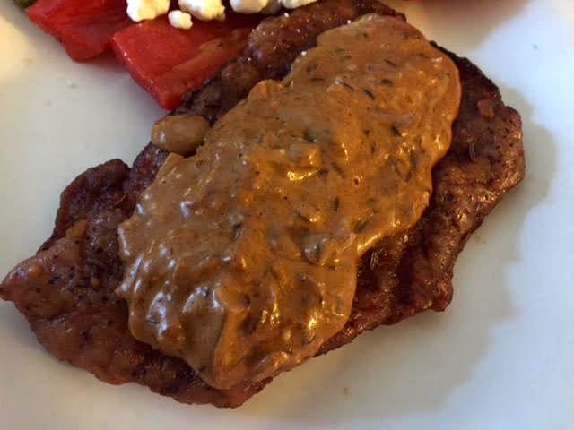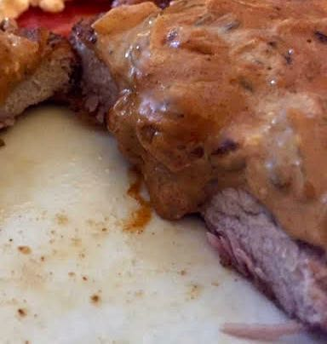

Ingredients:
2 boneless pork loin chops, trimmed of fat, or ½ pound pork tenderloin cut in half
3 tablespoons all-purpose flour
1 small shallot, minced
2½ teaspoons Hungarian paprika
1½ teaspoons caraway seeds
3 tablespoons dry white wine
½ cup chicken or beef broth
3 tablespoons crème fraîche or sour cream
½ teaspoon each salt and ground, black pepper
Vegetable oil, enough to cover the bottom of the pan you’re using by ½”

Preparation:
Preheat oven to 200° F. Set a wire rack over a foil- or parchment-lined baking sheet in the oven.

Sprinkle a small amount of water on a large sheet of plastic wrap (I use a gallon Ziploc). Place half of the pork on top of the plastic (or in the Ziploc) and sprinkle again with water. Cover with another sheet of plastic wrap (or just zip up the Ziploc) and pound with a rolling pin or meat pounder until about ¼“ thick. Repeat with the remaining pork chop.

Mix the flour with the salt and pepper in a paper bag. Heat the oil in a large skillet over medium-high heat until almost smoking. Place the cutlets in the flour mixture in the bag and shake it up well so that the pork chops are coated on all sides. Shake off the excess flour and add them into the skillet. Sauté until golden, about 1 minute per side. Transfer to the rack in the oven to keep warm while you make the sauce.

Add the shallot, paprika and caraway seeds to the pan. Sauté for 1 minute, then add the wine. Simmer, stirring to pick up and browned bits on the bottom, until almost dry. Add the broth and simmer for 3 minutes. Return the pork to the skillet (turn off oven) and simmer, turning often, until warmed through and the sauce is thickened, about 1 minute. Transfer to warmed serving plates. Stir the sour cream into the pan juices and season with salt and pepper. Spoon over the pork. Serve at once with boiled noodles, Spätzle or Hungarian fried cabbage and noodles.

