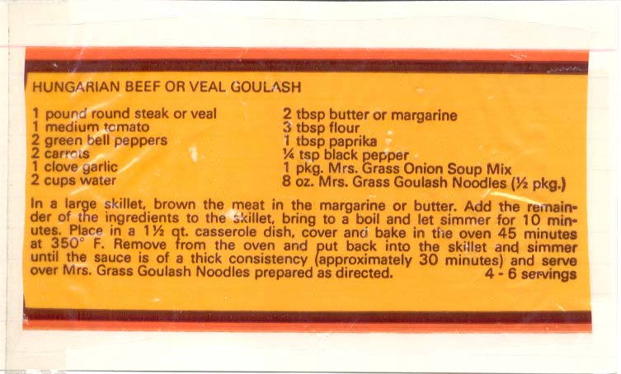 I don’t know what package of what I clipped this recipe off of, but (with the exception of the Mrs. Grass onion soup) it’s so primitive that you just know somebody got it out of his or her Hungarian Baba’s recipe book! Here’s how I’ve cleaned it up for two servings (I refuse to believe that fresh, chopped onion was not an ingredient, so I have added some)!

INGREDIENTS:

½ lb. beef rump roast, cut into 1” dice
1, 400-gram (@ 14 oz.) can whole, tinned tomatoes with their juice – crushed by hand
¼ - ½ cup onion, coarsely, but finely chopped
1 green bell pepper, coarsely, but finely chopped
1 medium-sized carrot, coarsely, but finely chopped
2 fat cloves fresh garlic, minced
1 cup water
1 – 2 TBS. butter
4½ teaspoons flour
1 TBS. hot, Hungarian paprika, plus a little extra to finish
½ - ¾ envelope Mrs. Grass onion soup powder mix
8 oz. fresh, lasagna pasta, cut into ½” x 2”-long pieces
salt, ground, black pepper and garlic powder

PREPARATION:

Melt the butter in a small skillet over high heat until it starts browning. Season the cubed beef with salt, freshly-ground black pepper and some garlic powder. Brown the seasoned beef cubes well on all sides in the butter. Add in the water and sprinkle in the flour, paprika and soup mix. Bring to a boil and allow to thicken. Add in the onion and garlic and simmer for just a minute or two.

Layer the carrot and green pepper in a small slow-cooker. Pour in the beef mixture and then the tomatoes. Mix it up. You can let it sit in the fridge overnight, then cook on “Low” 8 hours. Boil the noodles. Serve the goulash over the plated, boiled noodles.

