Czech Beef Stew with Gherkins, Mushrooms & Paprika (recipe serves 2).

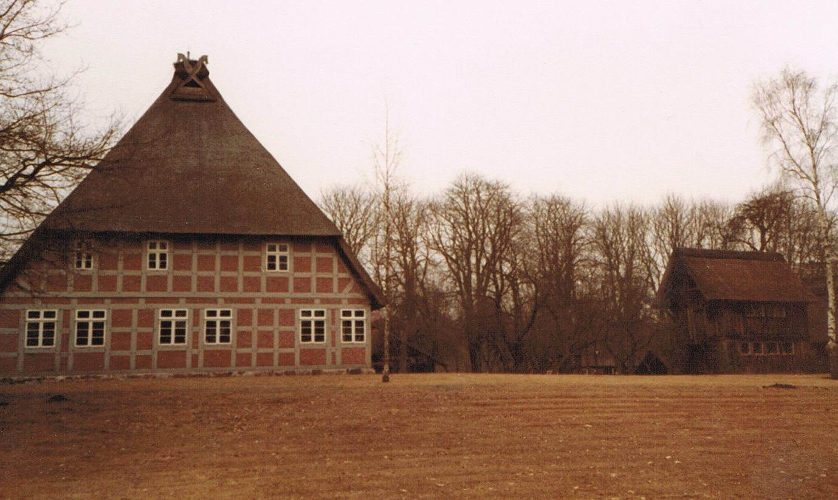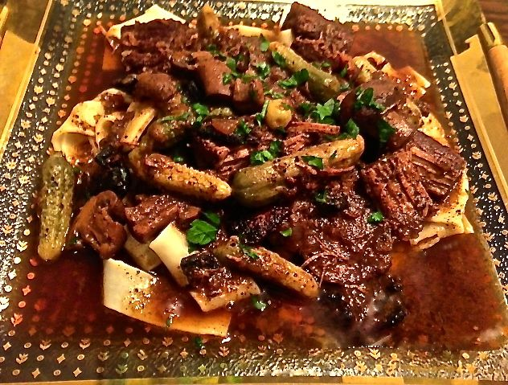

A unique recipe, I prepare the slow-cooker pot for this recipe the night before, storing the prepared pot in the fridge until morning. It works out great!

Ingredients:
2 thick slices Black Forest bacon cut in 1” pieces (I use kitchen sheers to cut it)
½ pound beef, cut into 1” – 2” pieces (I use rump roast)
¼ teaspoon salt
⅛ teaspoon pepper
4 ounces mushrooms, thickly sliced
1 small onion, halved and sliced
1½ teaspoons Hungarian-style paprika
¼ cup dry red wine (a good kind that you actually drink)
¾ cup beef broth
4 ounces small gherkins (itty-bitty pickles – what the French call “cornichons”)
1 teaspoon fresh parsley, finely chopped for garnish – divided in half for each serving
Preparation:
Fry bacon in a medium-sized skillet. Set aside. Season the beef with the salt and pepper and fry it in the bacon fat. Add to a small (2-quart) slow cooker when it is browned.
Sauté onions and mushrooms in the bacon fat, until the onions begin to color. Add to slow cooker.
Add all the rest of the ingredients to the slow cooker, except for the gherkins and bacon. Cover and cook for 6 hours on the high setting or 12 hours on low. Stir in pickles and bacon and allow to heat through before servings.

Serve over boiled noodles garnished with the parsley, with crusty bread on the side.

