Hungarian Chicken Paprika (“Paprikash”) with Egg Noodles for Two

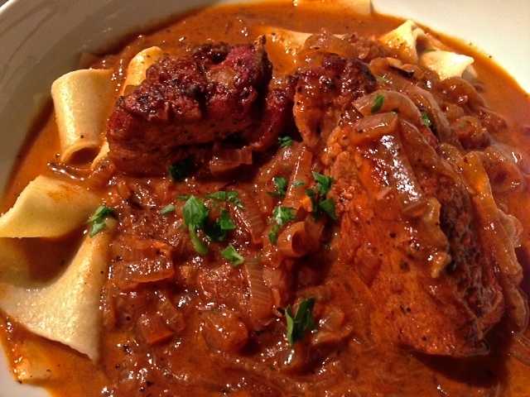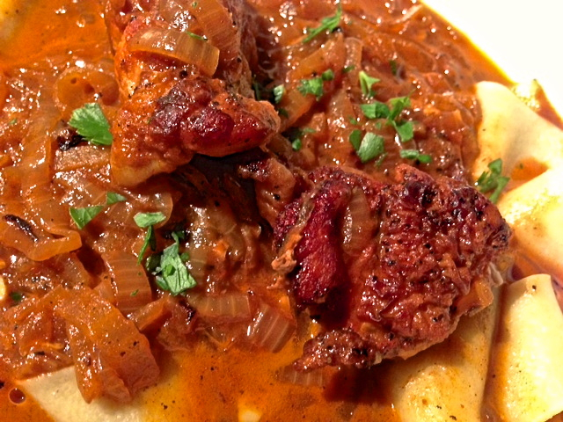

Ingredients;
½ pound chicken, cut into 4 pieces (I like using a boneless breast with skin on)
2 large yellow or white onions (about 2 pounds total), halved and thinly sliced
1 ounce butter
2 cloves garlic, minced
1½ - 2 teaspoons hot, Hungarian paprika
1 tablespoon tomato paste
½ cup chicken broth, hot
Salt and ground, black pepper, to taste
¼ cup crème fraîche or sour cream
4 ounces egg or other broad noodles
1 teaspoon fresh parsley, minced for garnish

Preparation:
Pat the chicken dry with paper towels and lightly season with salt and pepper. In a large saucepan over medium-high heat, brown the chicken well, starting with skin-side down. This is not to cook it through, but just to give it color. Remove the chicken and set aside.

Add the onions, a sprinkling of salt and pepper, and butter over medium-high heat until soft and a darkly caramelized. Add the garlic, paprika, tomato paste, and the chicken. Add the broth. Cover and simmer over low heat for 45 minutes, or until the chicken is cooked through and tender.

While the chicken cooks, boil the noodles according to package directions. Keep warm until the chicken is ready.

When the chicken is done, cut off the heat and stir in the crème fraîche or sour cream and serve over the noodles. It looks pretty with a little chopped parsley sprinkled over the top.

