Cabbage Roll Soup (recipe makes 4 servings)

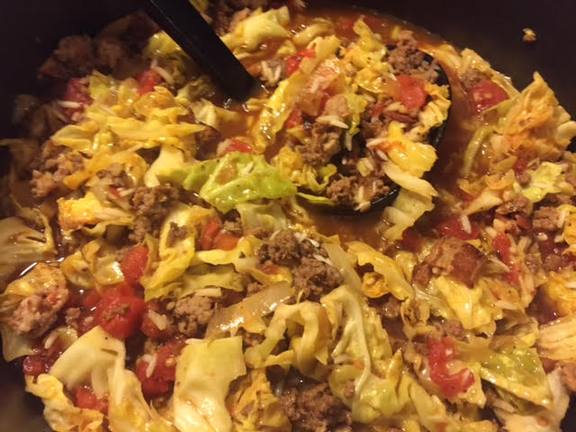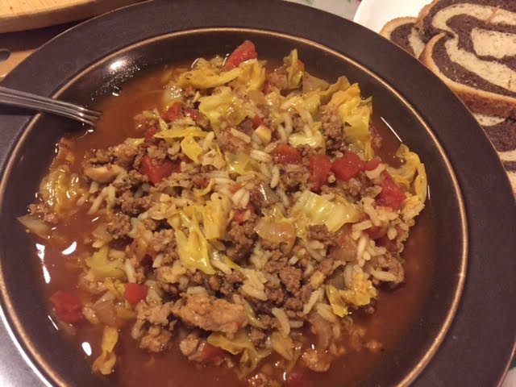

Ingredients:
6 strips bacon, chopped
3 cups (about ½ small head) chopped Savoy cabbage
1 cup large-diced onion (1 medium onion)
4 cloves garlic, minced
½ pound ground beef
¼ pound ground pork or pork sausage
½ cup uncooked long grain rice
1 tablespoon tomato paste
¼ teaspoon crushed chili flakes
½ teaspoon smoked paprika
1½ teaspoons oregano
½ teaspoon thyme
½ teaspoon caraway seeds
1 smaller bay leaf
14 ounces canned, diced tomatoes
1½ teaspoons Worcestershire sauce
2¼ teaspoons red wine vinegar (or your favorite non-balsamic vinegar)
2 cups beef broth
1 cup vegetable stock or broth
Salt and ground black pepper, to taste

Preparation:
Heat a large, heavy-bottomed pot over medium-high heat. Add the chopped bacon, and cook for 5 to 7 minutes, or until crisp. Add the diced onion, minced garlic and cook until translucent. Add the ground beef and pork; cook until the meat is cooked halfway. Add the long grain rice and cook for 2 to 3 minutes, or until toasted. Add the tomato paste, the crushed chili flakes and the smoked paprika, caraway seeds and bay leaf. Stir in the chopped cabbage, and let cook until slightly softened. Add the diced tomatoes, Worcestershire sauce, red wine vinegar, beef broth, vegetable stock, oregano and thyme to the pot.

Cover with the lid, and bring to a boil. Reduce the heat to maintain a simmer and cook for 15 – 25 minutes, or until the rice is fully cooked. Check the seasoning, remove the bay leaf and serve warm with rye bread on the side.

