Bigos - Polish Hunter’s Stew (recipe serves 2).

 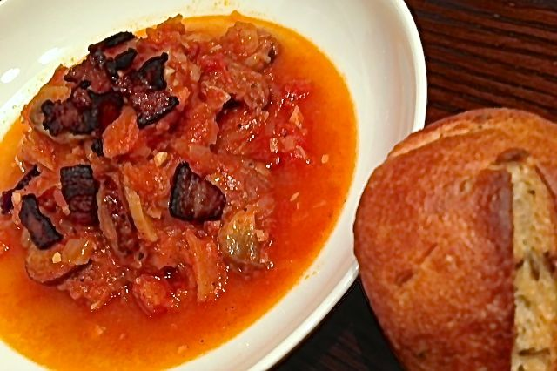 The national dish of Poland.

Ingredients:
2 slices bacon, chopped (I use kitchen sheers to cut it into square bits)
¼ pound Polish sausage/kielbasa, sliced
¼ pound ham, cut into ½ “ cubes
¾ cup white/pale sauerkraut, drained (I use Frank’s Bavarian style with caraway)
1 small white or yellow onion, finely chopped
1 small carrot, peeled and finely chopped
½ an average granny smith or other sweet-tart apple (only about 3 ounces or the bigos will be too sweet), peeled, quartered, cored and thinly sliced
1 clove garlic, minced
2 – 3 ounces fresh button mushrooms, thinly sliced
1, 14.5-ounce can whole, peeled tomatoes, well crushed by hand, with their juices
3 tablespoons dry, red wine, like Cabernet Sauvignon
¼ teaspoon salt & ⅛ teaspoon ground, black pepper
⅛ teaspoon caraway seeds (leave out if using Frank’s Bavarian style with caraway)
1 teaspoon prepared, coarse-grain mustard (I like Gulden’s brand)

Preparation:
In a large, heavy-bottomed saucepan, fry the bacon until crisp. Use a slotted spoon or fork to remove the bacon from the pot and set it aside (reserve the rendered bacon fat in the pot). Lightly fry the ham and sausage in the rendered bacon fat until just browned; add in the onion, carrot, apple, garlic and mushrooms and sauté until the onion turns translucent – add a little olive oil if you need to in order to insure everything is coated well with fat.

Stir in the wine and deglaze the pot (scrape up and dissolve any browned bits which might be sticking to the bottom of the pot, if any remain after sautéing the vegetables). Add in the crushed tomatoes and their juices, the salt, pepper, caraway seeds and sauerkraut. Cover the pot and simmer on very low heat (just so the stew bubbles gently) for 45 minutes to an hour (the longer you let it simmer, the better it will be!). Check for seasoning, then stir the mustard in well. Ladle into serving bowls and sprinkle the reserved bacon on top. Serve with boiled potatoes or boiled egg noodles, and crusty bread. Of course, you’ll want to wash this down with cold Polish beer!

