Welsh Rarebit Soufflés

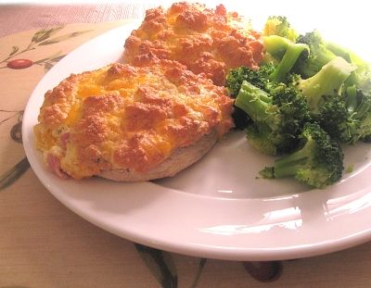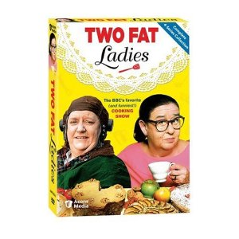

Two Fat Ladies’ Recipe (adapted – serves two, 1 muffin each).

Ingredients:

2 English muffins, divided and toasted
8 oz. good, English Cheddar cheese
4 eggs
1 teaspoon brown mustard
1 teaspoon Worcestershire sauce
1 teaspoon hot sauce
1 Tablespoon parsley (fresh or dried)
½ cup diced cooked ham (optional)
freshly ground black pepper to taste

Preparation:

1. Preheat oven to 450 degrees.
2. Shred the cheddar into a medium mixing bowl.
3. Divide the eggs. Place 3 egg yolks, ham, parsley, mustard, Worcestershire sauce, hot sauce and pepper into the bowl with the cheddar and mix (sorry, but you’ll have to save the 4th egg yolk for another recipe!).
4. Whip four egg whites until stiff peaks form.
5. Add a large spoonful of the whipped egg whites into the cheese mixture and combine.
6. Gently fold the remaining egg whites into the cheese mixture. You want the mixture to remain as fluffy as possible.
7. Place English muffins onto a baking tray. Spoon mixture over the English muffin halves, spreading gently to cover.
8. Bake 10-15 minutes, until browned and risen.

