Sticky Toffee Pudding (recipe makes 4 – 6 servings)

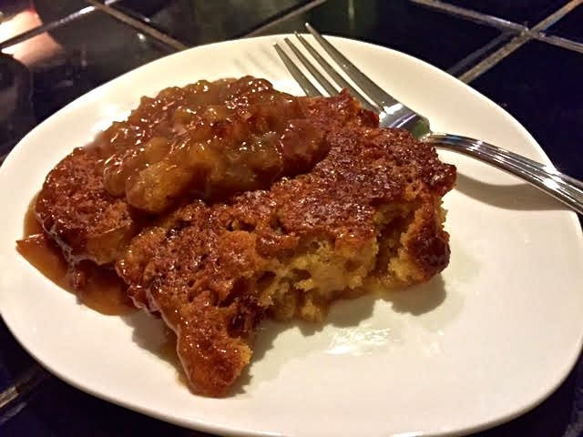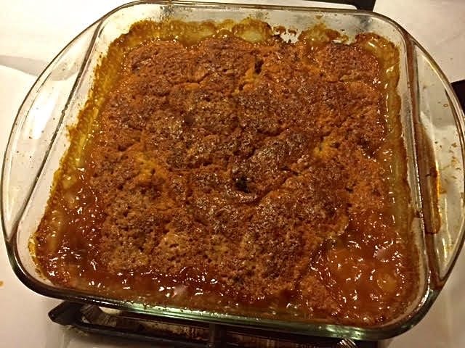

This quintessential English dessert is easy to make and absolutely scrumptious.

Ingredients:
1 cup all-purpose flour
½ cup demerara/turbinado sugar and a separate ⅔ cup demerara/turbinado sugar
1½ teaspoons baking powder
¼ teaspoon salt, plus a separate ¼ teaspoon salt
½ cup whole milk
¼ cup unsalted butter, melted
2 tablespoons unsalted butter, cubed
1 teaspoon vanilla extract
1 large egg
¾ cup chopped, pitted dates
Zest of 1 very large orange
The juice of the orange (about ½ cup’s worth)

Preparation:
Preheat the oven to 375° F.

Whisk together the flour, the ½ cup sugar, baking powder and the first ¼ teaspoon salt in a large bowl. In another bowl, whisk together the milk, melted butter, vanilla extract and egg. Fold the wet ingredients into the dry ingredients until just blended. Fold in the dates. Spread the batter evenly in a greased, high-sided, 8” square casserole.

Sprinkle the ⅔ cup sugar over the batter. Dot with the butter cubes, and sprinkle the ¼ teaspoon salt and orange zest evenly over the top. In a saucepan, combine the orange juice with 1¾ cups water. Bring to a boil and pour over the batter.

Bake for 1 hour on the middle rack of the oven. The pudding is done when the cake's center springs back when touched and the sauce, which has collected at the bottom of the casserole, is syrupy and bubbling.

