Steak, Stout & Cheddar Pie

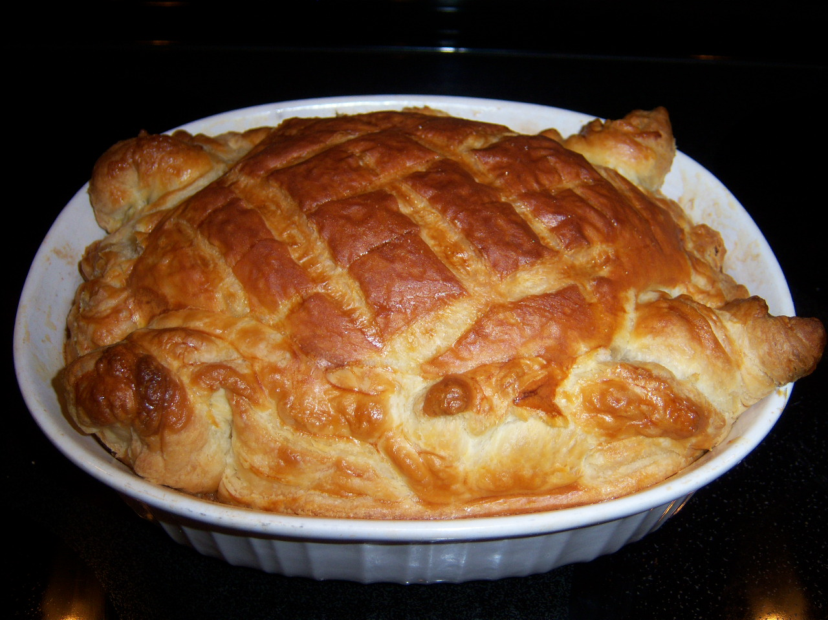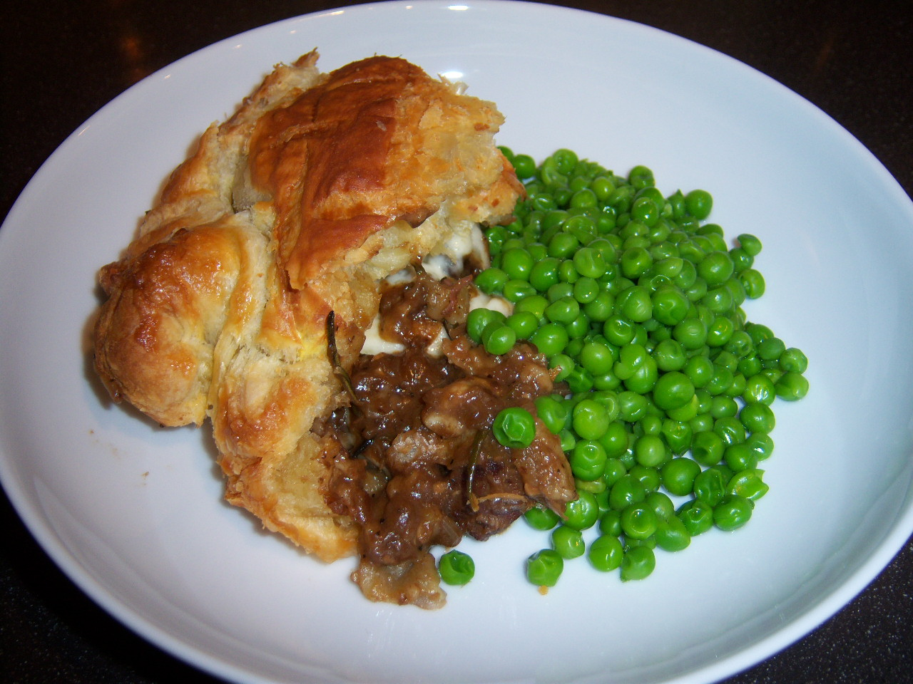

Mind that this luscious, rich meaty dish, although not complicated, has quite a few steps and requires about four hours to make. But it’s so worth it!

Ingredients:
2 pounds beef brisket, cut into ¾“ cubes
3 medium red onions, peeled and chopped into ½” dice
3 – 4 cloves of garlic, peeled and minced
1 ounce butter, plus extra for greasing
2 carrots, peeled and chopped into ½” dice
2 ribs celery, trimmed and chopped into ½” dice
8 ounces baby portabella/crimini mushrooms, peeled and sliced into ¼” pieces
1 teaspoon dried rosemary
1 tall can Guinness, Murphy’s or other brand of stout beer (just under a pint)
2 heaping tablespoons all-purpose flour
7 – 8 ounces freshly-grated, English Cheddar cheese
2 sheets (17 – 18 ounces) thawed, commercial puff pastry (I use Pepperidge Farms)
1 large egg, beaten
Olive oil
Salt and ground, black pepper, to taste

Preparation:
Preheat the oven to 375º F.

In a large, ovenproof pan, heat a couple tablespoons of olive oil on a medium-low heat. Add the onions and fry gently until soft – try not to color them too much. Turn the heat up, add the garlic, butter, carrots and celery and scatter in the mushrooms. Mix everything together before stirring in the beef, rosemary, a teaspoon each of salt and pepper (I season with salt and pepper as I go).
Increase heat to a boil and reduce the pan juices, if any, by about half, then pour in the stout, stir in the flour and add just enough water to cover if there’s not enough juices doing so. Place uncovered in the preheated oven for about 2½ hours, stirring the stew every 30 minutes, until the meat is very tender and the stew is rich, dark and thick. Remove the rosemary stems. Remove from the heat and stir in half the cheese, then leave to cool slightly.

Butter a 2- to 2½-quart casserole dish. Using a rolling pin, stretch out one of the puff-pastry sheets so that it’s large enough to line the bottom of the casserole, leaving the edges dangling over the side. Tip the stew into your lined casserole and even it out before sprinkling over the remaining cheese. Brush the edges of the pastry with a little beaten egg. Fit the top of the pie with the other sheet of pastry (leave it thick) and criss-cross lightly with a sharp knife. Fold the overhanging pastry on to the pastry lid, crimping the edges to make it look nice and rustic.

Brush the top with beaten egg, then bake the pie directly on the bottom of the oven for 45 minutes, until the pastry is cooked, puffed and golden.

Delicious served simply with hot, buttered peas.

