Scotland Fried Herring with Mustard Sauce

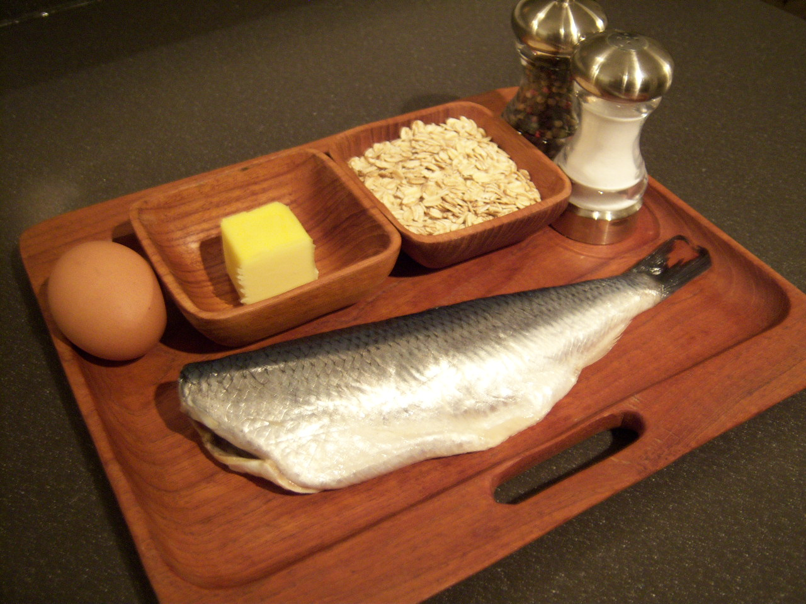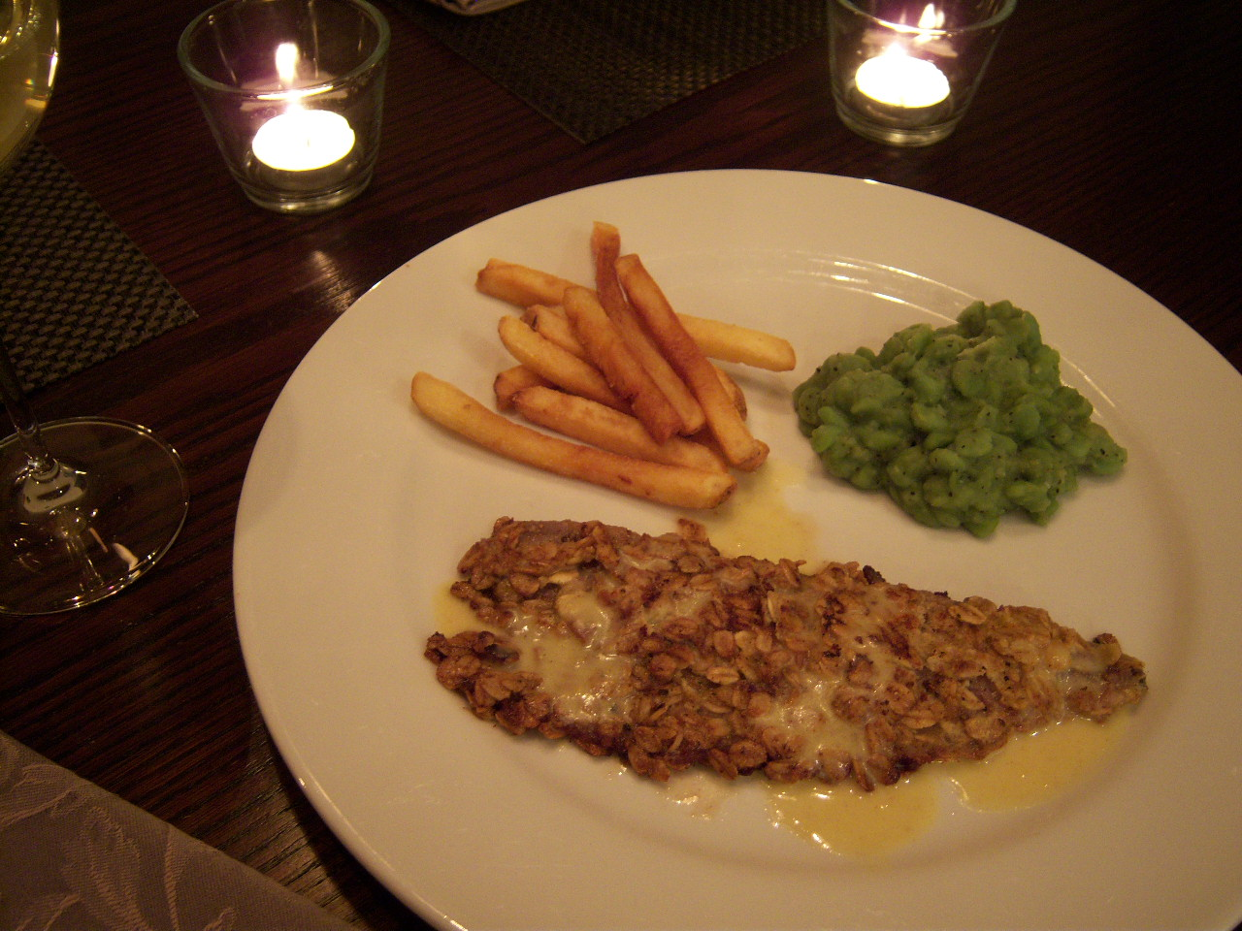

This recipe is charmingly rustic and simple. The only hard thing about it is procuring the fresh herring fillets (see my notes below). No salt is added – the herring is salty enough.

Ingredients:

For the Mustard Sauce
1 tablespoon butter
1 tablespoon all-purpose flour
¼ cup milk
2 teaspoon dry mustard
¼ teaspoon ground, white pepper
To prepare the mustard sauce, melt the butter in a small saucepan. Whisk in the flour and gradually add the milk. Stir until thickened, then blend in the mustard and pepper. This can also be done in the microwave. On low power, melt the butter for about 15 seconds in a large, microwave-safe bowl. Blend in the flour, then the milk. Heat on full power for 20 - 30 seconds, then blend in the mustard and pepper. If the sauce seems a little too thick, just add a bit more milk until it reaches a consistency that pleases you. Remove to the side and keep warm.

For the Fish
2 fresh herring fillets (see notes below)
1 egg, beaten
½ cup coarse oatmeal
2 tablespoons butter
Ground, black pepper, to taste
Preparation:
Dip the fillets in the egg and coat them with the oatmeal. Melt the butter in a skillet and fry the herring on medium heat until it's tender and the coating is nicely browned, about 8 to 10 minutes (if the oatmeal starts popping, it's done for sure). Season the fillets well with ground, black pepper before serving.

Serve with the mustard sauce, "chips" (French fries) or any other type of fried potatoes and a nice pint of stout (dark beer). This recipe only yields enough for two servings, but it is very filling (and you can always make more).
Notes:
Though the proximity of the United States to the Canadian eastern seaboard makes fresh herring widely available in the United States, it's not in such demand that it's commonly stocked in the average American supermarket. So, unless you live in or near the largest of American cities, don't expect to be able to just pop right into your local grocery store to buy fresh herring fillets. Depending on the season (fresh herring is more readily available in late summer and in the fall), you will probably have to make special arrangements with your grocer's seafood department to order the fresh herring far in advance of the day you plan on making these (we live in about the 20th largest city in the U. S., and I still have to special-order them well ahead of time).

As an alternative to fresh herring fillets, when they're difficult to come across, try smoked/kippered herring from a tin. There are enough Canadian companies out there selling us the plain, smoked fillets in large sardine tins, so they're not nearly as hard to get a hold of as fresh herring, and they work great in this recipe.

You'll need 3 to 4 ounces of tinned fillets per serving. Kippered, tinned herring adds a really nice, smoky note to the dish, so don't be too shy to try this short cut (just make sure you get plain, smoked fillets - not any that are packed in some kind of sauce or dressing).

