Scotch Eggs

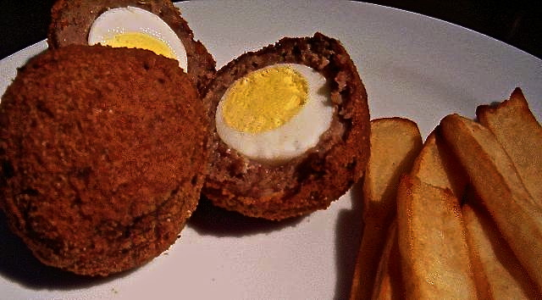

These may not be the healthiest things in the world to eat, but they are among my absolute favorites. Before I got this wonderfully easy recipe from a friend, I had always been under the impression that Scotch eggs were impossibly difficult to prepare oneself at home. Not so!

Ingredients:
4 medium or 6 small hard-boiled eggs
1 pound pork or turkey sausage meat
½ cup all-purpose flour
2 eggs, beaten
¾ cup fine breadcrumbs
Vegetable oil for deep-frying

Preparation:
Fill deep fryer or a medium-sized saucepan about ¾ of the way up with oil and heat to between 325° F. and 350° F. Peel eggs and set aside. Divide sausage meat into as many equal portions as you have eggs. Roll each egg in flour (optional - see notes below) and mold a portion of the sausage around each egg. Dip each sausage-wrapped egg into the beaten eggs, then roll in breadcrumbs.

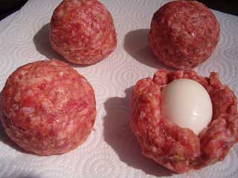

Cook each egg in oil about 6 - 10 minutes, or until dark brown in color. Drain on paper toweling.

Notes:
If you're a health freak like me, use egg substitutes (like Egg Beaters) to dip them in before coating with the breadcrumbs. I use really lean turkey sausage (mild Italian flavored) in this recipe and it tastes super! The last time I made these, I forgot to roll the eggs in the flour before coating them with the sausage, and it worked out fine (so you can omit the messy flour, if you prefer). Also, though it's still very fattening to fry food, you can actually do your heart some good by frying in a cholesterol-lowering fat like canola, peanut, soy, safflower or corn oil. My doctor says that even people with high cholesterol can eat two or three eggs a week without negative health implications, so two or three of these once in a blue moon shouldn't hurt at all.

I have found that some restaurants serve these cut in half because the chefs want to take a look inside to be sure the sausage is cooked all the way through before they send them out to the table. To avoid having to cut them to see if they're cooked all the way through, just pop them in the microwave for one minute on "high" after you're finished frying them all up. That way, you can be sure that they're fully cooked and serve them intact to your guests! Serve with spicy brown mustard and HP sauce on the side (for dipping). These go great with chips, “mushies” (mushy marrowfat peas) and a pint (or two) of good Scottish ale, like Belhaven!

Mary, Queen of Scots (1542 – 1587) was actually from France!

