English Salt Beef (recipe serves 8 – 10)

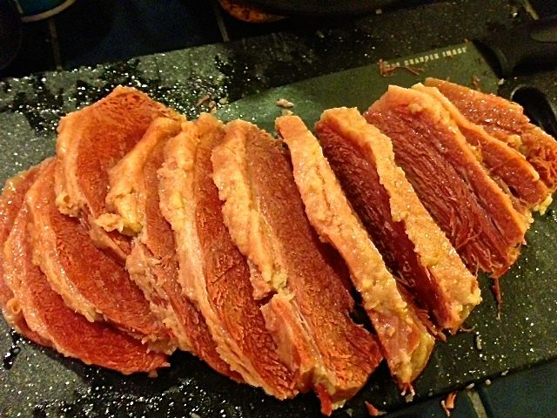

This is the English way to make what we call “corned beef.” It’s very popular in the U.K. Traditionally, saltpetre or sodium nitrite is used in the salting mixture to keep the meat pink. The Spice House in Milwaukee carries it, but it's not essential.

Ingredients:
4½ - 5 pound beef brisket – have your butcher roll it up into a roast with string
½ cup soft light brown sugar
2 cups coarse/Kosher sea salt
2 teaspoons black peppercorns
2 teaspoons juniper berries
1 tablespoon coriander seeds
6 bay leaves
1 tablespoon mustard seeds
5 teaspoons saltpeter/ sodium nitrite (pink curing salt - optional)
1 large carrot, cut into large chunks
1 onion, unpeeled and quartered across the root
1 celery stick, cut into chunks
1 leek, roughly chopped and thoroughly rinsed under cold, running water
Handful of parsley stalks
6 garlic cloves, unpeeled but slightly smashed open
2 scallions, sliced into large sections

Preparation:
Place the sugar, salt, peppercorns, juniper berries, coriander seeds, 4 bay leaves, mustard seeds and saltpetre in a large stew pot. Add a gallon of water and bring to the boil, stirring, until the sugar has dissolved. Simmer for 2 minutes. Remove from the heat and leave until cold.

Pierce the piece of beef all over with a skewer. Place in a large clean heavy duty polythene bag (I use turkey-baste bags) or a sterilized plastic food tub. Add the cold, spiced liquid and seal the bag or cover the container, making sure the meat is covered by the liquid. Leave in the fridge for 7 days, turning everyday.

Rinse the meat thoroughly in cold water. Place in a large stockpot with the vegetables, parsley stalks, remaining bay leaves and garlic. Cover with water, bring to the boil and simmer gently for 3½ hours, partially covered, until tender. Remove to a cutting board, snip off the string, then cut into thick slices or tear into pieces with two forks. The cooking liquid turns into a lovely beef stock that you can save and use in other recipes!

