Quick and Easy Salisbury Steak

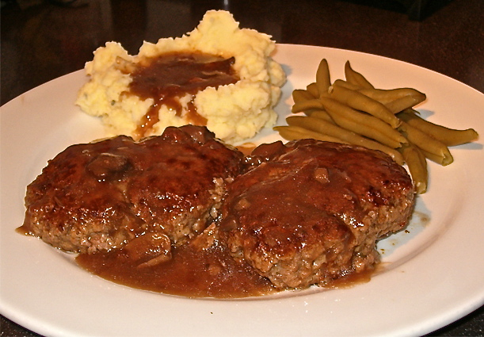

When all things German were given anglicized names in Great Britain during WWII, hamburger steak (as in Hamburg, Germany) was renamed "Salisbury steak." So that's strong evidence that indicates this dish was, in fact, named after the town of Salisbury, England.

Ingredients:
1, 10½-ounce can (or 1, 12-ounce jar) of any commercial brand mushroom gravy
½ pound ground sirloin or the leanest variety of ground beef you can find
6 tablespoons dry breadcrumbs (see note)
1 tablespoon dehydrated, chopped onion bits (rehydrated in 1 tablespoon water) or ¼ of a small (about 1½ ounce) onion, very finely minced
½ egg, beaten (see note)
1½ teaspoons Worcestershire sauce
1 teaspoon salt
1 teaspoon ground, black pepper

Preparation:
Mix ¼ cup or less of the canned gravy with the beef, breadcrumbs, onion, Worcestershire sauce, salt, pepper and egg thoroughly together in a large mixing bowl. Don't add so much gravy that the mixture becomes sloppy - you want it to adhere together rather firmly, so just add gravy, little by little, to the meat to the point where the mixture is still firm (you probably won't need a whole fourth of a cup). Shape the mixture firmly into two equal, oval patties about ¾” to 1" thick.

In a large skillet over medium-low heat, heat 1 tablespoon of any oil you like and brown the patties in it. Pour off any fat and add the remaining gravy. Heat to a boil, then cover and cook on low heat 10 to 15 minutes. I love serving this with seasoned mashed potatoes and green beans.

Note:
I use egg substitute (Egg Beaters), and it works great. Commercially-made, seasoned breadcrumbs work quite nicely with this recipe, but why not make your own?

