MULLIGATAWNY STEW – British-style curry chicken stew (makes 4 servings)

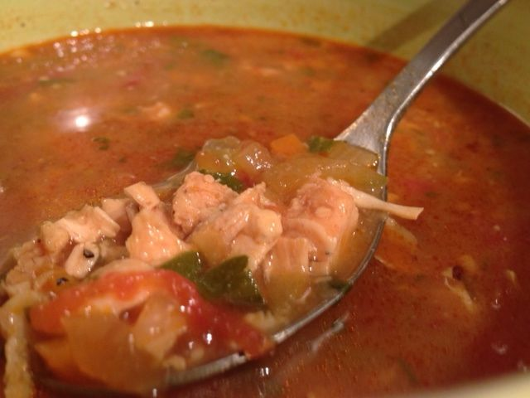 This slightly sweet, sour, spicy, very fresh and clean chicken soup is the perfect prescription for hangovers and the common cold!

INGREDIENTS:
8 oz. cooked chicken, finely diced or shredded
¼ - ½ cup onion (a medium-small one), finely chopped
2 cloves garlic, minced
2 heaping teaspoons curry (sambar) powder
2 tablespoons oil
half of a tart apple (about ¼ cup’s worth), peeled & finely chopped
¼ cup carrot, very finely chopped
¼ cup celery, very finely chopped
1 – 2 Serrano chili peppers, finely chopped
3 tablespoons flour
4 cups chicken broth
1, 16-oz. can tomatoes, crushed by hand and juices retained
1 tablespoon parsley, chopped
2 teaspoons lemon juice
1 teaspoon sugar
2 whole cloves
salt & ground, black pepper

PREPARATION:
In a large saucepan, heat the oil until just smoking. Sauté the onion, garlic and curry powder in the oil, season with a light sprinkle of salt & pepper and cook until the onion is tender and golden.

Stir in the apple, carrot, celery and chilies. Season with another light sprinkling of salt & pepper. Cover and cook on medium-low heat, stirring occasionally, until the vegetables are crisp-tender (about 5 minutes). Sprinkle the flour over the vegetables mixture, stirring well. Cook for about a minute to get rid of the rawness of the flour.

Slowly stir in the broth, tomatoes & their liquid, parsley, lemon juice, sugar, cloves and a final sprinkle of salt & pepper. Bring to a boil. Add the chicken, then simmer on very low heat, stirring occasionally, for at least 30 minutes, up to 3½ hours (improves with time).

Serve with warm, Indian naan or roti bread. Fish out the cloves before serving!

