Irish Soda Bread – recipe makes a large loaf (about 8 servings – you may cut the ingredients in half to make a smaller loaf).

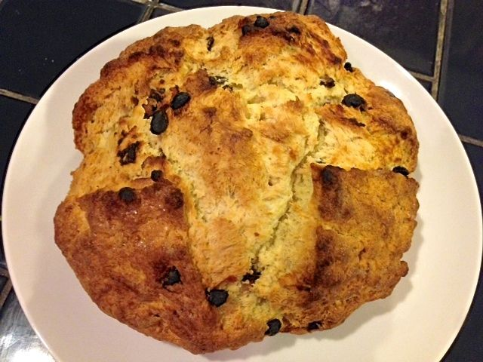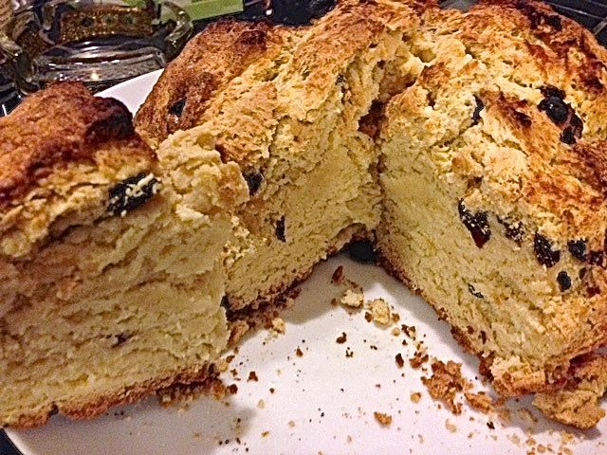

Ingredients:
4 cups all-purpose flour
4 tablespoons white sugar, plus enough to sprinkle over the top before baking
1 teaspoon baking soda
1 tablespoon baking powder
½ teaspoon salt
½ cup butter, softened
1 cup buttermilk
¼ - 1 cup raisins (optional)
1 egg
¼ cup butter, melted

Preparation:
Preheat oven to 375° F. Line a baking sheet with foil or baking parchment.

In a large bowl, mix together the flour, sugar, baking soda, baking powder, salt and the ½ cup softened butter. Stir in 1 cup of buttermilk, egg and, if including them, the raisins. Turn dough out onto a lightly floured surface and knead slightly. Form dough into a round and place on prepared baking sheet. Brush the loaf liberally with the melted butter. Sprinkle more sugar over the top, then use a sharp knife to cut an 'X' into the top of the loaf.

Bake in preheated oven until a toothpick inserted into the center of the loaf comes out clean, 45 to 50 minutes. Check for doneness after 30 minutes. You may continue to brush the loaf with the melted butter while it bakes. Let cool before serving.

