Irish-Style, Corned-Beef Hash for Two

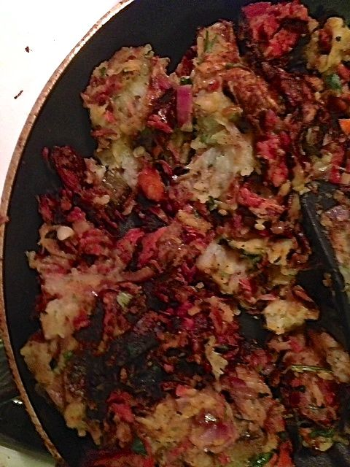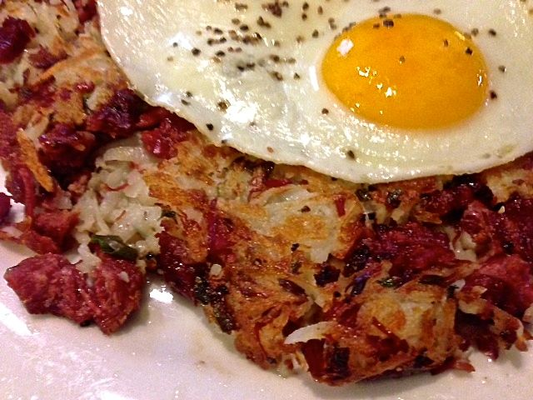

Ingredients:
½ pound pickled corned beef
1 medium carrot, roughly sliced
1 small, white onion, roughly chopped
1 rib celery, roughly chopped
3 whole cloves
3 whole peppercorns
1 bay leaf
3 tablespoons white wine vinegar
2 large, red-skinned potatoes, washed, but unpeeled
1 small (about 2 ounces) red onion, minced
1 scallion/green onion, finely chopped
3 tablespoons (or more, to taste) flat-leaf parsley, chopped
½ teaspoon salt and ground, black pepper
2 teaspoons olive oil

Preparation:
Place the whole piece of corned beef in a large saucepan and cover with cold water. Add the carrot, onion, celery, cloves, peppercorns, bay leaf and vinegar to the pot and simmer, covered, at a low boil 2 hours, or until the corned beef is fork tender and crimson red in color. Skim any foam occasionally that rises to the top so you have a clear stock when finished boiling.

Meantime, boil the potatoes whole and unpeeled in the saucepan with the corned beef and vegetables for twenty minutes – you may have to adjust the heat to bring the water back up to the boil after adding them. Remove them from the saucepan and allow to cool, then grate them in a bowl. They will feel like they’re not cooked, but that’s what you want – they need to be a little sticky and gluey so they hold the finished hash together.

When the corned beef is fork tender, remove it from the saucepan, reserving the rich stock for use in other recipes. Slice the corned beef, then cut the slices into thin strips. Dice the strips finely and mix them thoroughly into the grated potatoes with the red onion, scallion, parsley, salt and pepper.

Grease a medium skillet with 1 teaspoon of the olive oil and bring it up to medium heat. Evenly spread the hash mixture into the hot skillet and allow to fry for 10 – 12 minutes, until browned on the bottom. Using a plate large enough to cover the hash in the skillet, invert the hash upside down into the plate – use caution because you might get splashed with hot oil! Grease the skillet again with the other teaspoon of oil, let it come back up to medium heat and carefully slip the hash on the plate back into the skillet to brown the other side another 10 minutes.

Serve the hash topped with a fried egg.

