Home-Made Bangers – recipe makes 4 sausages (2 per serving)

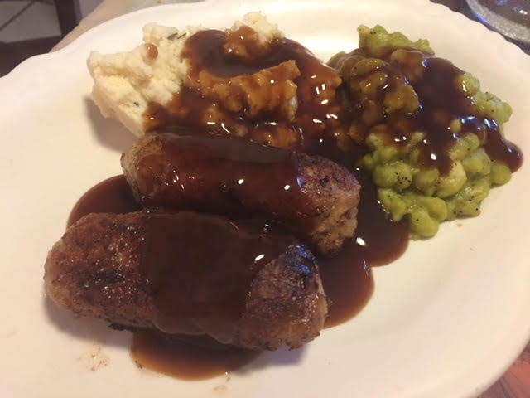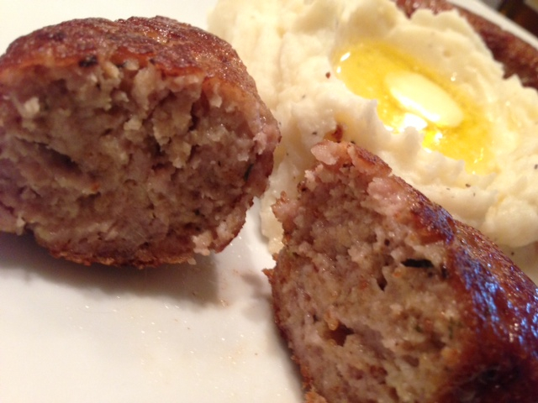

Ingredients:
½ pound ground pork or seasoned sausage meat, bulk/out of casing
1 ounce fresh breadcrumbs
1 small egg, or ½ a large (beat egg, then divide evenly in half)
1 garlic clove, minced
¼ teaspoon ground thyme
⅛ teaspoon ground, dry mustard
⅛ teaspoon onion powder
½ teaspoon salt
¼ teaspoon ground, black pepper
Instructions:
Beat the egg to a froth in a large bowl and mix together with the rest of the ingredients except the olive oil. Divide the mixture into 4 pieces and shape each one into a sausage. Try to keep them uniform with one another. Set aside until you want to cook them.

Heat a frying pan on medium-low heat, add a tablespoon olive oil and gently fry the sausages low and slow for 12 – 15 minutes, until golden on all sides and cooked through.

Traditional, English bangers and mash call for serving sausages cradled in a mound of mashed potatoes with “mushy” peas and covered all over with brown gravy. But I like serving the bangers along side 6-ounce servings of mashed potatoes with just a simple dollop of butter in the potatoes.

