English-Style Tomato Soup for Two

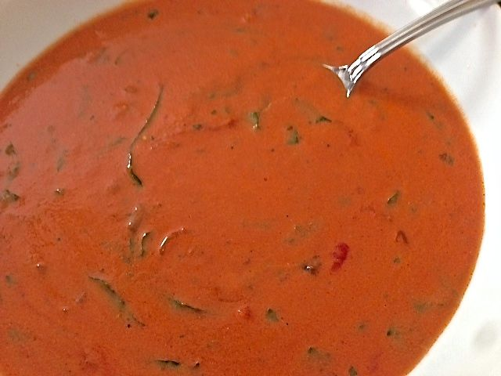

The Brits take a tip from the Italians by combing basil with tomatoes in this rich, elegant soup. I first had it when I was in the army and on temporary duty stationed at a British Intelligence unit in West Germany back in the mid ‘80s.

Ingredients:
3 tablespoons melted butter
1 small onion, diced
1, 680-g. bottle (about 24 ounces total) Italian tomato passata, or tomato juice – I shake ½ teaspoon each of salt, ground, black pepper & Italian, red-wine vinegar into the bottle
1, 14-ounce can whole San Marzano tomatoes, crushed
1½ teaspoons Knorr Aromat seasoning
4½ teaspoons sugar
¼ teaspoon salt
¼ teaspoon freshly ground, black pepper (i.e., from your pepper grinder – required)
½ cup sherry
¾ cup heavy cream
Chopped fresh parsley, 1 – 2 tablespoons or to taste
Julienned fresh basil, 1 – 2 tablespoons or to taste

Preparation:
Sauté onions in butter until translucent. Add tomatoes, tomato juice, Aromat, sugar, salt and pepper; stir together well. Bring to a near boil, then turn heat down to very low and simmer, covered, for 30 minutes.

After it simmers, shut off the heat and stir in the sherry, cream and fresh herbs. Adjust other seasonings and serve with crusty bread.

