English Chicken Hotpot

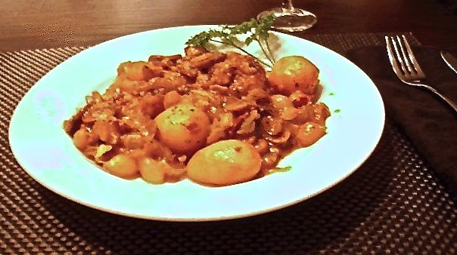

I said it in my first cookbook and I’ll say it again here: I could eat this every day of the week because it’s just that good. An all-in-one, farmhouse dish with new potatoes included, "hotpot" is an old cooking method in England. This is an absolutely fabulous dish from the English countryside. More palatable to American tastes than its famous cousin made mostly with organ meat and other offal, Lancashire hotpot, this makes a handsome addition to any American cook's chicken-recipe repertoire.

Ingredients:
½ pound chicken pieces (leg with thigh portions, or split breasts, cut in half)
1 heaping tablespoon all-purpose flour seasoned with ⅛ teaspoon each of salt, ground, black pepper and granulated garlic powder
1 tablespoon unseasoned flour (to thicken sauce)
1 tablespoon butter and about a tablespoon olive oil (to fry meat & vegetables)
4 ounces tiny new potatoes, peeled (canned will do nicely)
1 small garlic clove, crushed or finely minced
½ cup pearl onions, peeled (frozen work great)
1 slice streaky bacon, raw, diced
1 rib celery, sliced
2 – 4 ounces button mushroom (a 4-ounce can of stems & pieces will do)
Salt and ground, black pepper, to taste
½ cup chicken broth
½ teaspoon paprika
⅛ teaspoon dried dill weed
⅛ teaspoon ground marjoram
⅛ teaspoon ground sage
⅛ teaspoon dried basil
1 small bay leaf
Fresh, chopped parsley (to garnish)

Preparation:
Preheat oven to 350° F.

Toss the chicken in the seasoned flour (I shake it all up in a paper bag). Melt the butter in a frying pan, add the oil and brown the chicken until golden all over.

Place browned chicken in a small casserole/baking dish and add the potatoes.
Brown the bacon to a crisp in the pan you browned the chicken, then add in the garlic, onions, celery and mushrooms. Cook for a few minutes to warm everything through, then add the unseasoned flour and stir well. Add the broth gradually, stirring constantly, until thickened. Add the herbs and paprika, and check seasoning. Pour over the chicken and potatoes in the baking dish.

Add the bay leaf, cover and cook for 1 hour, until the meat is tender and cooked through.
Remove the bay leaf and garnish with the parsley. This recipe is a meal in itself and needs nothing but fresh bread served on the side.

