Bacon & Onion Pie (recipe makes 2 – 4 servings)

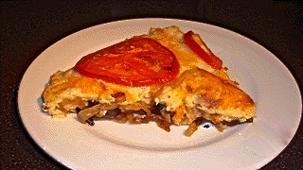

The crispy-browned bacon melds perfectly with the savory, caramelized onions. Together with the cheesy, mashed-potato topping covered by the tangy, roasted tomatoes, it makes for a heavenly little brunch component or a fine main dish.

Ingredients:
2 cups mashed potatoes
1 tablespoon vegetable oil
4 - 5 ounces bacon, cut into 1"- 2" pieces
4 ounces butter, divided
2 medium-sized, white onions, halved and finely sliced
¼ teaspoon sugar
5 ounces English or other Cheddar cheese, grated
1 medium, red-ripe tomato, thinly sliced
Salt and ground, black pepper, to taste

Preparation:
Make your mashed potatoes, or warm them through if they've been sitting in the fridge for any amount of time. Set them aside and keep warm.

Heat and cook the bacon in half the butter and all the oil in a large saucepan until just beginning to brown and crisp. Remove from the pot with a slotted spoon.

Add the onions to the grease in the pan. Add seasoning to taste, and the sugar. Fry gently over medium heat until the onions are soft and caramelized. Take care not to burn them! Return the bacon to the pan and stir evenly through the onions. Pour the mixture evenly into a standard-sized (9") pie pan.

Add the remaining butter and 4 ounces of the cheese to the potatoes. Season with salt and pepper to taste and mix well. Preheat the oven broiler to the highest setting.

Spoon the potato-cheese mixture evenly over the onions and bacon, sprinkle evenly with the remaining cheese, top decoratively with the slices of tomato and season the tomatoes with just a touch more salt. Place pie under the broiler until the cheese is melted and the top is nicely browned in spots. Serve with buttered green peas.

